PROJECT REPORT (KEC-851)

On

EMOTION DETECTION USING DEEP LEARNING

Submitted for partial fulfillment of award of the degree of

Bachelor of Technology

In

Electronics and Communication Engineering

Submitted By

Aman Gangwar – 1901920310015
Ankit Raj – 1901920310022
Duvesh Chauhan – 1901920310055
Nidhish Kumar Singh - 1901920310095

Under the Guidance of

Dr. Mohan Singh
(Associate Professor)



Deptt. of Electronics and Communication Engineering
G. L. BAJAJ INSTITUTE OF TECHNOLOGY AND MANAGEMENT
Plot no. 2, Knowledge Park III, Gr. Noida
Session: 2022-23 (Even Sem)

DECLARATION

We certify that

- The work contained in this Project Report is original and has been done by us under the guidance of my supervisor.
- The work has not been submitted to any other University or Institute for the award of any other degree or diploma.
- We have followed the guidelines provided by the University in preparing the Report.
- We have confirmed the norms and guidelines in the Ethical Code of Conduct of the University.
- Whenever we used materials (data, theoretical analysis, figures, and texts) from other sources we have given due credit to them by citing them in the text of the report and giving their details in the references. Further, we have taken permission from the copyright owners of the sources, whenever necessary.

Date: 25-April-2023 Signature:
Place: Greater Noida Aman Gangwar
1901920310015
Signature:
Ankit Raj
1901920310022
Signature:
Duvesh Chauhan
1901920310055
Signature:
Nidhish Kumar Singh
1901920310095



Deptt. of Electronics and Communication Engineering
G. L. BAJAJ INSTITUTE OF TECHNOLOGY AND MANAGEMENT
[Approved by AICTE, Govt. of India & Affiliated to A.K.T.U (Formerly U.P.T.U), Lucknow]

CERTIFICATE

Certified that Aman Gangwar(1901920310015), Ankit Raj(1901920310022), Dubesh Chauhan(1901920310055), Nidhish Kumar Singh(1901920310095) have carried out the project work (Project -II, KEC-851) presented in this report entitled “Emotion Detection using Deep Learning” for the award of Bachelor of Technology in Electronics and Communication Engineering during the Academic session 2022-23 from Dr. A.P.J. Abdul Kalam Technical University (Formerly U.P.T.U), Lucknow. The project embodies result of the work and studies carried out by Student himself and the contents of the report do not form the basis for the award of any other degree to the candidate or to anybody else.

(Dr. Mohan Singh) (Dr. Piyush Yadav)
(Project Guide) (Project Coordinator)
(Associate Professor) (Associate Professor)
Deptt.of ECE Deptt.of ECE

(Dr. Satyendra Sharma)
HOD, Deptt. Of ECE

Date: 25-April-2023

ABSTRACT

Humans can effortlessly pick out emotions using their senses, which as computer are imaginative and prescient and seeks to mimic human vision by means of analyzing the digital image as enter. For humans to stumble an emotion will not be a difficult task to perform. Detecting emotion via voice for example detecting ‘stress’ in a voice with the aid of setting parameters in areas like tone, pitch, pace, volume, and so forth in the case of virtual photos detecting emotion simply by using analyzing photos is novel way. In this model, we are looking to design a convolutional neural network version that may classify the input photo into 7 exclusive feelings. The respected feelings we are going to classify are angry, disgust, contempt, happy, sad, surprise and neutral. In order to classify these emotions, we're implementing Convolutional Neural Networks (CNNs) which can successfully and accurately elucidate semantic information coming from the faces in an automatic manner. We also apply some data augmentation techniques to intercept over fitting and under fitting problems. The Result of this version shows that it works higher if it has more set of pics to research. The proposed version achieves more than 90% accuracy.
Here, we also recognizing age and gender of an individual which is trained to predict age and gender using a broad ResNet framework. The Broad ResNet framework can be effectively utilized for age and gender recognition tasks. The framework's ability to capture complex features and patterns, coupled with appropriate dataset preparation and training, can enable accurate and robust predictions for age and gender identification in images.

ACKNOWLEDGEMENT

In the absence of mother, the birth of a child is not possible and in the absence of teacher the right path of knowledge is impossible. This project is by far the most significant accomplishment in our life and it would be impossible without people who supported us and believed us.
We would like to extend my gratitude and my sincere thanks to my honorable, esteemed guide Dr. Mohan Singh (Associate Professor (ECE)), Department of Electronics and Communication Engineering, GL Bajaj, Greater Noida for their immeasurable guidance and valuable time that he/she devoted to the project. We sincerely thank for their exemplary guidance and encouragement. His trust and support inspired us in the most important moments of making right decisions and we are glad to work with him.
We would also like to give very special thanks to our HOD Sir Dr. Satyendra Sharma. Also, we would also like to give thanks to our project coordinator Dr. Piyush Yadav (Associate Professor (ECE)), and my teachers for their support, help and encouragement during this work.
We would like to thank all my friends for all the thoughtful and mind stimulating discussions we had, which prompted us to think beyond the obvious.
We enjoyed their companionship so much during my stay at GL Bajaj, Greater Noida. We would like to thank all those who made my stay in GL Bajaj, Greater Noida, an unforgettable and rewarding experience.
A boat held to its moorings will see the floods pass by; but detached of its moorings may not survive the flood. The support of all the members of our family (especially our parents, our sisters and brothers) motivated us to work even while facing the blues. We dedicate this work to them.
Aman Gangwar (1901920310015)
Ankit Raj (1901920310022)
Duvesh Chauhan (1901920310055)
Nidhish Kumar Singh (1901920310095)

TABLE OF CONTENT

Declaration | Page No.  ii
Certificate | iii
Abstract | iv
Acknowledgements | v
Table of Contents | vi-vii
List of Tables | viii
List of Figures | ix
Abbreviations | x
CHAPTER 1: INTRODUCTION | 1-8
1.1 Introduction | 1
1.2 Objective | 4
1.3 Motivation with problem formulation | 6
1.4 Methodology | 6
1.5 Structure of project report | 6
CHAPTER 2: LITERATURE SURVEY | 9-12
CHAPTER 3: PROPOSED METHODOLOGY | 13-26
3.1 Proposed methodology | 13
3.2 System Architecture | 14
3.3 Data sets of speech emotion recognition | 15
3.4 Speech Architecture of CNN | 17
3.5 Feature of audio files | 18
3.6 Classification model | 19
3.7 Face emotions | 20

3.8 CNN model | 23
3.9 Feature extraction | 24
CHAPTER 4: TECHNICAL SPECIFICATION | 27-36
4.1 Classification using machine learning | 27
4.2 Deep learning implementation | 28
4.2.1 Neural network | 30
4.2.2 Convolutional neural network | 30
4.3 Technology learnt | 31
4.4 System specification | 36
CHAPTER 5: CONSTRAINTS ALTERNATIVES & TRADEOFFS | 37-42
5.1 System specification | 37
5.2 Classification | 37
CHAPTER 6: RESULT & DISCUSSION | 43-65
6.1 Execution speed | 43
6.2 Code | 48
6.3 Result | 53
CHAPTER 7: CONCLUTION & FUTURE WORK | 66
7.1 Conclusion | 66
7.2 Future Work | 66
REFERNCES | 67
USER MANUAL | 71
LIST OF PUBLICATION | 72
APPENDIX | 73
CERTIFICATES | 82

LIST OF FIGURE

Figure No. | Figure Name | Page No.
3.1 | System architecture | 20
3.2 | ARCHITECTURE OF CNN | 21
3.3 | PROPOSED TRAINING MODEL | 22
3.4 | PROPOSED TESTING MODEL | 23
3.5 | DROPOUT LAYER | 25
3.6 | PROPOSED FEATURE EXTRACTION  METHOD | 26
4.1 | SEQUENCE DIAGRAM | 27
4.2 | USE CASE DIAGRAM | 28
4.3 | ACTIVITY DIAGRAM | 29
4.4 | COLLABERATION DIAGRAM | 30
5.1 | EXTRACTING IMAGES FROM DATASETS | 32
5.2 | SPEECH EMOTION LAYERS OF CNN | 33
5.3 | FACE EMOTION LAYERS OF CNN | 35
5.4 | RESULTING ACCURACY OF SPEECH  EMOTION | 36
5.5 | MODEL LOSS | 38
5.6 | AUDIO RECORDING | 39
5.7 | RESULTS & OUTPUTS OF FACE EMOTION | 40
5.8 | OUTPUTS OF SPEECH EMOTION | 41

LIST OF TABLE

3.5.3 | FACE DATASETS COUNT | Page No.  16
4.2 | COMPARISON OF ALGORITHM ACCURACY | 35

LIST OF ACRONYMS

CNN | CONVOLUTION NEURAL NETWORK
MPL | MULTIPLE PERCEPTRON
LSTM | LONG SHORT - TIME MEMORY
MFCC | MEL FREQUENCY CEPSTRUM COEFFICIENTS
LPCC | LINEAR PREDICTION CEPSTRUM COEFFICIENTS
ANN | ARTIFICIAL NEURAL NETWORK
SVM | SUPPORT VECTOR MACHINE
RNN | RECURRENT NEURAL NETWORK
PLP | PERCEPTUAL LINEAR PREDICTION

CHAPTER 1 INTRODUCTION

Introduction
In latest years, the interaction amongst human beings and computers has been continuously evolving, reaching a smooth purpose of natural interaction. The most expressive way for human beings to express their feelings is through facial expressions. Humans have little or no try to find and interpret facial and facial expressions inside the scene. Still, growing an automatic device to accomplish this challenge remains pretty difficult. There are several related problems: the class of expressions (eg, within the emotional class), detecting photograph segments as faces and extracting facial features records. A device that correctly performs those operations within the actual global could be a crucial step in reaching similar human interactions among people and machines. Predicting age, gender, and emotion is vital for social sciences and research. Researchers can utilize deep learning and machine learning algor to efficiently gather demographic information for studies, enabling deeper insights into how age, gender, and emotions influence human behavior and decision-making processes. These predictive capabilities contribute to a better understanding of societal dynamics and facilitate evidence-based research. Human emotion detection is implemented in many areas requiring additional security or information about the person. It can be seen as a second step to face detection where we may be required to set up a second layer of security, where along with the face, the emotion is also detected. This can be useful to verify that the person standing in front of the camera is not just a 2-dimensional representation [1]. Another important domain where we see the importance of emotion detection is for business promotions. Most of the businesses thrive on customer responses to all their products and offers. If an artificial intelligent system can capture and identify real time emotions based on user image or video, they can make a decision on whether the customer liked or disliked the product or offer. We have seen that security is the main reason for identifying any person. It can be based on fingerprint matching, voice recognition, passwords, retina detection,etc. Identifying the intent of the person can also be important to avert threats. This can be helpful in vulnerable areas like airports, concerts and major public gatherings which have
seen many breaches in recent years. Human emotions can be classified as: fear, contempt, disgust, anger, surprise, sad, happy, and neutral. These emotions are very subtle. Facial muscle contortions are very minimal and detecting these differences can be very challenging as even a small difference results in different expressions [4]. Also, expressions of different or even the same people might vary for the same emotion, as emotions are hugely context dependent [7]. While we can focus on only those areas of the face which display a maximum of emotions like around the mouth and eyes [3], how we extract these gestures and categorize them is still an important question. Neural networks and machine learning have been used for these tasks and have obtained good results. Machine learning algorithms have proven to be very useful in pattern recognition and classification. The most important aspects for any machine learning algorithm are the features. In this paper we will see how the features are extracted and modified for algorithms like Support Vector Machines [1]. We will compare algorithms and the feature extraction techniques from different papers.

The following categories of feelings are distinguished:

i. Anger: Here, we are recognizing anger using facial expressions, which is done using Convolutional Neural Networks (CNNs), which is a type of deep learning algorithm commonly used for image analysis tasks.
ii. Disgust: The success of disgust recognition with CNNs relies on factors such as the quality and diversity of the training dataset, the model architecture, and the training process.
iii. Fear: Recognizing fear using facial expressions through Convolutional Neural Networks (CNNs) follows a similar process as recognizing anger or disgust.
iv. Surprise: A diverse dataset is needed for a better result because surprise and fear expressions are very similar to each other.
v. Happiness: It is easy to recognize the happiness expression since it is not similar to any other facial expression.
vi. Neutral: Recognizing neutrality requires less computation power since fewer neural networks are required to recognize neutral expressions.
vii. Sad: To ensure the success of sadness recognition with CNNs, it is crucial to have a diverse and well-labeled dataset that includes a range of facial expressions of sadness.

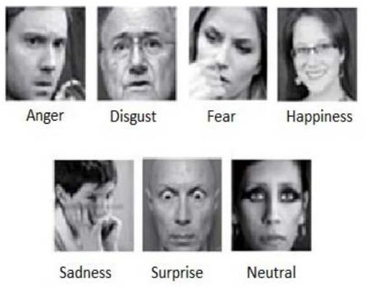

Figure. 1. Various emotions which are detected by the program [7]

The human emotion dataset can be a very good example to study the robustness and nature of classification algorithms and how they perform for different types of datasets. Usually before extraction of features for emotion detection, face detection algorithms are applied on the image or the captured frame. We can generalize the emotion detection steps as follows: 1) Dataset preprocessing 2) Face detection 3) Feature extraction 4) Classification based on the features. In this work, we focus on the feature extraction technique and emotion detection based on the extracted features. Section 2 focuses on some important features related to the face. Section 3 gives information on the related work done in this field. Related work covers many of the feature extraction techniques used until now. It also covers some important algorithms which can be used for emotion detection in human faces. Section 4 details the tools and libraries used in the implementation. Section 5 explains the implementation of the proposed feature extraction and emotion detection framework. Section 6 highlights the result of the experiment. Section 7 covers the conclusion and future work.
Here, we also recognizing age and gender of an individual which is trained to predict age and gender using a broad ResNet framework. few examples of their uses are as the utilization of age and gender prediction plays a significant role in content recommendations. Online platforms, such as streaming services and e-commerce websites, leverage this information to offer personalized recommendations to their users. By considering the user's age and gender, these platforms can suggest movies, TV shows, products, or services that align with their preferences, enhancing the overall user experience and driving engagement. range of practical applications across different domains. Apart from this, it can use Within the healthcare domain, age and gender prediction can be valuable in various ways. For example, in telemedicine applications, automated identification of age and gender can assist healthcare providers in gathering initial demographic information from patients. This information can be used to deliver appropriate healthcare services and tailor treatment plans to specific age groups and genders. for predicting age and gender we use The Broad ResNet architecture is a variant of the ResNet (Residual Network) model that has wider layers to improve feature representation. It is commonly used in computer vision tasks such as age and gender identification. When using the Broad ResNet architecture for age and gender identification, the model typically takes an image as input and processes it through a series of convolutional layers, followed by pooling and fully connected layers. Here's a high-level overview of how age and gender identification can be performed using the Broad ResNet architecture.1) Input Image: The input image is fed into the Broad ResNet architecture. It is usually preprocessed by resizing and normalizing the image to a fixed size.2) Convolutional Layers: The image is passed through several convolutional layers. These layers are responsible for extracting features from the image at different spatial scales. Each convolutional layer applies a set of filters to the input image, generating feature maps that highlight different patterns and texture.3) Pooling Layers: After each set of convolutional layers, pooling layers are used to down sample the feature maps. Pooling helps reduce the spatial dimensions of the feature maps while retaining important information.4) Fully Connected Layers: The output from the last pooling layer is flattened and fed into fully connected layers. These layers are responsible for learning high-level representations of the features extracted from the image. They capture complex relationships between features and enable the model to make predictions.5) Age and Gender Prediction: The fully connected layers are connected to separate output layers for age and gender prediction. The number of nodes in the age output layer corresponds to the number of age categories or a continuous regression value. Similarly, the gender output layer has nodes representing different genders (e.g., male and female).6) Training: The model is trained using a labeled dataset where each image is annotated with its corresponding age and gender. During training, the model's parameters are adjusted using techniques like backpropagation and gradient descent to minimize the prediction error.7) Inference: After training, the model can be used for age and gender identification on unseen images. The input image is passed through the trained network, and the output nodes for age and gender provide predictions. The age category or continuous value and the gender with the highest activation can be considered as the model's identification results. When using the Broad ResNet architecture for age and gender identification, several factors can influence the model's performance. Firstly, the exact architecture details may differ based on specific implementations and modifications for this task. These adaptations could involve altering the number and arrangement of convolutional layers, pooling layers, and fully connected layers. Secondly, the quality and diversity of the training data are critical considerations. Annotated datasets containing images labeled with age and gender information are used to train the model. Ensuring that the training data is representative of the target population is crucial for achieving accurate predictions. Thirdly, the techniques employed during training significantly impact the model's performance. Common techniques such as back propagation and gradient descent are utilized to adjust the model's parameters based on the training data. This process enables the model to learn from the data and optimize its performance by minimizing prediction errors. In terms of model architecture, the age prediction component typically consists of an output layer with nodes corresponding to specific age categories or a continuous regression value. Similarly, the gender prediction component includes an output layer with nodes representing different genders, such as male and female. During the inference phase, the trained model can be used to predict the age and gender of new, unseen images. The input image undergoes processing through the trained network, and the output nodes for age and gender provide predictions. The model's identification results are determined by considering the age category or continuous value, as well as the gender with the highest activation. It’s crucial to note that the performance of the age and gender identification model relies on various factors, including the specific architecture design, the quality and representativeness of the training data, and the training techniques employed. Continuous evaluation and validation are necessary to ensure accurate and reliable predictions. The field of age and gender identification using the Broad ResNet architecture is continuously evolving, with ongoing research and advancements refining the architecture and techniques to achieve improved performance.

While predicting emotion in CNNs can be trained on large datasets of facial expressions or speech recordings with annotated emotion labels. The CNN learns to identify patterns and features in the data that are indicative of specific emotions. This approach is called supervised learning. The first step in emotion detection using CNNs is to preprocess the data. For facial expressions, this involves extracting relevant features such as facial landmarks, facial expressions, and head pose. For speech recordings, this involves extracting features such as pitch, intonation, and spectral features. These features are then fed into the CNN as input. The CNN consists of multiple layers, including convolutional layers, pooling layers, and fully connected layers. In the convolutional layers, the CNN applies filters to the input data to extract features. The pooling layers down sample the feature maps to reduce the dimensionality of the data. The fully connected layers use the extracted features to predict the emotion label. Training the CNN involves minimizing a loss function that measures the difference between the predicted emotion label and the true emotion label. This is done using an optimization algorithm such as stochastic gradient descent (SGD). Once the CNN is trained, it can be used to predict the emotion label of new facial expressions. The CNN takes the preprocessed data as input and outputs a probability distribution over the possible emotion labels. One of the advantages of using CNNs for emotion detection is their ability to automatically learn relevant features from raw data. This eliminates the need for manual feature engineering, which can be time-consuming and error-prone. Additionally, CNNs can capture complex patterns and relationships in the data that may be difficult to capture using traditional machine learning methods.

There are several challenges in emotion detection using CNNs. One of the main challenges is the availability of labeled data. Emotion detection datasets are often small and may not represent the diversity of emotions and expressions in real-world situations. Another challenge is the generalization of the CNN to new domains and contexts. The CNN may not perform well on new data that is different from the training data. AI algorithms for age, gender, and emotion prediction offer benefits but face physical challenges. Accuracy and bias issues may arise, especially for unique individuals or subtle expressions. Input quality affects performance, requiring standardized data. Privacy concerns surround personal data usage. Ethical implications include discrimination and stereotype reinforcement. Interpretation and contextual understanding may be limited. Overcoming challenges requires research, fairness, transparency, and user education. Striving for accuracy, robustness, and unbiased outcomes is crucial. It is also crucial to consider ethical considerations and privacy protection when deploying AI systems for age, gender, and emotion prediction. Responsible and fair use of these technologies must be upheld to safeguard individuals' privacy rights and avoid any potential biases or discrimination.

Deep Learning
Deep learning is a subfield of machine learning that focuses on training artificial neural networks to learn and make intelligent decisions from data. It is inspired by the structure and function of the human brain, specifically the interconnected network of neurons.

At the core of deep learning are artificial neural networks, which consist of layers of interconnected nodes, known as artificial neurons or units. These units receive inputs, apply mathematical operations to them, and produce output activations. The connections between the units have associated weights that determine the strength of influence one unit has on another. Deep learning architecture is typically composed of multiple layers of interconnected units, forming a deep neural network. The term "deep" refers to the depth of the network, which is characterized by the number of layers it contains. Each layer performs feature extraction and transformation, learning progressively more complex representations of the input data as information flows through the network. Training a deep neural network involves a two-step process: forward propagation and backpropagation. During forward propagation, input data is fed into the network, and activations are calculated through the layers until reaching the output layer. The calculated output is then compared to the desired output to compute a loss or error value. In backpropagation, the error is propagated backward through the network, and the weights and biases of the network are adjusted iteratively to minimize the error. This process utilizes optimization algorithms, such as stochastic gradient descent (SGD) or its variants, to update the weights and biases based on the computed gradients of the loss function with respect to the network parameters. One of the key advantages of deep learning is its ability to automatically learn and extract hierarchical representations from raw data. By using multiple layers, deep neural networks can learn to capture abstract and complex features from the input data, enabling them to model highly intricate patterns and make accurate predictions. Deep learning has achieved remarkable success in various domains, including computer vision, natural language processing, speech recognition, and recommendation systems. Convolutional Neural Networks (CNNs) have been particularly effective in computer vision tasks, while Recurrent Neural Networks (RNNs) and their variants, such as Long Short-Term Memory (LSTM), have excelled in sequential data processing. Moreover, deep learning has benefited from the availability of large-scale labeled datasets, such as ImageNet and COCO, and advancements in computational resources, particularly Graphics Processing Units (GPUs), which can accelerate the training process. In recent years, deep learning has also seen the rise of pretraining and transfer learning. Pretraining involves training a deep neural network on a large dataset and then fine-tuning it on a specific task or domain. Transfer learning leverages pretrained models to extract useful features and knowledge from one task and apply them to another related task with limited labeled data.

Figure. 2

ANN

Artificial Neural Networks (ANNs) are computational models inspired by the structure and functioning of biological neural networks, such as the human brain. ANNs are a fundamental component of deep learning and are widely used for various machine learning tasks, including pattern recognition, classification, regression, and optimization. At its core, an ANN consists of interconnected artificial neurons, also known as nodes or units. These neurons receive inputs, apply mathematical operations to them, and produce an output signal. The neurons are organized into layers, including an input layer, one or more hidden layers, and an output layer. The connections between neurons in different layers have associated weights, which determine the strength of the influence one neuron has on another. The weights are initially assigned random values and are adjusted during the training process to optimize the network's performance. The flow of information in an ANN is typically forward, with inputs propagating through the layers to produce an output. Each neuron in a layer computes a weighted sum of its inputs, applies an activation function, and passes the result to the next layer. Common activation functions include sigmoid, ReLU (Rectified Linear Unit), and tanh (hyperbolic tangent), among others. The learning process in ANNs involves training the network on labeled data to adjust the weights and biases, enabling the network to learn patterns and make accurate predictions. This is typically done using supervised learning, where the network is presented with input-output pairs and updates its weight based on the error or loss between its predicted outputs and the true outputs. The training process often involves an optimization algorithm, such as stochastic gradient descent (SGD), to iteratively update the weights and minimize the loss function. Backpropagation, a technique used in ANNs, computes the gradients of the loss function with respect to the network's weights, allowing for efficient weight updates during training. ANNs can have various architectures, including feedforward neural networks, recurrent neural networks (RNNs), convolutional neural networks (CNNs), and more. Feedforward neural networks, also known as multilayer perceptrons (MLPs), have a simple structure with one or more hidden layers and are effective for many tasks. RNNs are designed to handle sequential data and have feedback connections that allow them to capture temporal dependencies. CNNs excel in image and spatial data processing, utilizing convolutional layers to extract local patterns and hierarchical representations. ANNs have been successful in various domains, including computer vision, natural language processing, speech recognition, and robotics. They have achieved state-of-the-art performance in tasks such as image classification, object detection, machine translation, and sentiment analysis. However, ANNs also have some limitations. They require large amounts of labeled training data to learn effectively, and training can be computationally intensive, especially for deep architectures. Overfitting, where the network becomes too specialized to the training data, is also a concern. Regularization techniques, such as dropout and weight decay, are commonly used to mitigate overfitting. Artificial Neural Networks are computational models inspired by biological neural networks. They consist of interconnected artificial neurons organized into layers and are trained on labeled data to learn patterns and make predictions. ANNs have achieved impressive performance in various machine learning tasks and are a core component of deep learning methodologies.
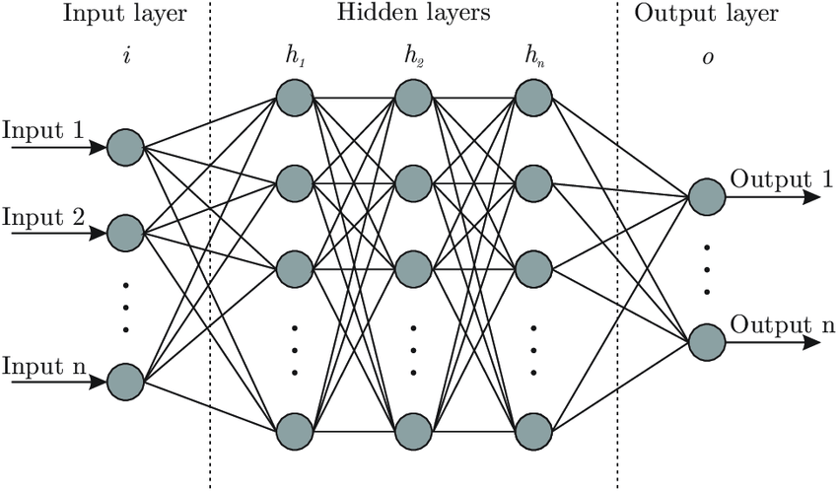

Figure. 3.

RNN

Recurrent Neural Networks (RNNs) are a type of artificial neural network that excel in processing sequential and temporal data. Unlike traditional feedforward neural networks, RNNs have feedback connections, allowing information to persist and be passed from one step to the next within the network. The key characteristic of RNNs is their ability to maintain an internal memory or hidden state, which allows them to capture dependencies and patterns over time. This memory is shared across all time steps, enabling the network to process sequences of varying lengths and model the context and history of the data. The basic building block of an RNN is a recurrent unit, often represented as a simple recurrent neuron or a more complex variant such as the Long Short-Term Memory (LSTM) or Gated Recurrent Unit (GRU). These recurrent units process an input at each time step, update their hidden state based on the current input and the previous hidden state, and produce an output. The forward pass in an RNN involves iterating over the input sequence one time step at a time, updating the hidden state and producing outputs at each step. The hidden state at each time step serves as a summary of the past information, capturing the context and dependencies up to that point. During training, RNNs are trained using a technique called backpropagation through time (BPTT). BPTT calculates the gradients of the loss function with respect to the network parameters at each time step and propagates them backward through time, enabling the network to learn from past inputs and adjust its weights. One challenge with traditional RNNs is the vanishing gradient problem, where gradients diminish as they are propagated back in time, making it difficult for the network to capture long-term dependencies. This problem led to the development of more sophisticated variants such as LSTM and GRU. LSTM introduces memory cells and gating mechanisms that allow the network to selectively store and access information over time. It has a more complex structure, including input gates, forget gates, and output gates, which control the flow of information and help address the vanishing gradient problem. GRU is a simplified version of LSTM that combines the input and forget gates into a single update gate, reducing the number of parameters and computations compared to LSTM while still capturing long-term dependencies effectively. RNNs have found success in various applications involving sequential data, including natural language processing (NLP), speech recognition, machine translation, sentiment analysis, and time series forecasting. They can process variable-length inputs and generate outputs of varying lengths, making them suitable for tasks where the order and context of the data are crucial. However, traditional RNNs have limitations in modeling very long sequences due to the vanishing gradient problem and can struggle with capturing long-term dependencies. In such cases, advanced architectures like Transformer models have emerged as alternatives, which use self-attention mechanisms to capture global dependencies more effectively. RNNs are a class of neural networks designed for sequential data processing. They utilize feedback connections and maintain hidden states to capture temporal dependencies and context. Variants like LSTM and GRU address the vanishing gradient problem and have been successful in various tasks requiring sequence modeling and prediction.
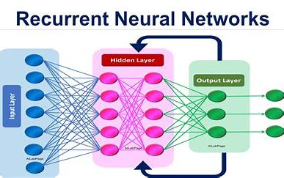

Figure. 4.

CNN

CNN, short for convolutional neural network, is a type of deep learning algorithm widely used in image and video processing. This neural network architecture is designed to automatically learn and extract essential features from input data, particularly photos. An excellent example of CNN's recent and significant use is for image classification on the ImageNet benchmark [21].The CNN processes the input data through a series of layers, including convolutional layers, pooling layers, and fully connected layers. The convolutional layers use learned filters to extract crucial features from the input data, while the pooling layers reduce the dimensionality of the convolutional layer output by down sampling it. The fully connected layers use the output of the convolutional and pooling layers to classify the input data.

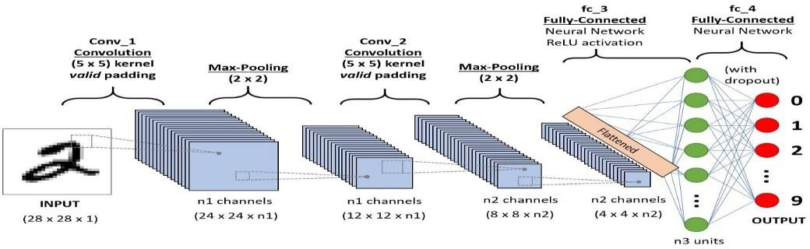
We will look more about in next chapter.

Figure. 5.

Xception Architecture

The Xception architecture is a deep convolutional neural network (CNN) architecture that was introduced by François Chollet in 2017. It is an extension of the Inception architecture and stands for "Extreme Inception." Xception is known for its exceptional performance in image classification tasks, achieving state-of-the-art results on various benchmarks. The key idea behind the Xception architecture is to replace the traditional inception modules used in the Inception network with depthwise separable convolutions. These depth wise separable convolutions aim to capture both spatial and channel-wise dependencies in the input data more effectively and efficiently. In traditional CNNs, convolutions are performed on both the spatial dimensions and the channels simultaneously. In Xception, depth wise separable convolutions decouple these operations. The first step involves performing a depth wise convolution, which applies a separate convolutional filter to each input channel independently. This captures spatial information. The second step is a pointwise convolution that applies 1x1 filters to combine the output channels from the previous step. This allows for cross-channel information exchange. The Xception architecture begins with an entry flow, which consists of several convolutional and pooling layers to process the input image. This initial part of the network performs basic feature extraction and down sampling, reducing the spatial dimensions while increasing the number of channels. Following the entry flow, the Xception architecture employs a series of residual-like modules in the middle flow. These modules consist of several stacked depth wise separable convolutional layers. The use of residual connections helps alleviate the vanishing gradient problem and allows for better gradient flow during training. The exit flow of the Xception architecture comprises a combination of global average pooling and fully connected layers. The global average pooling layer aggregates the spatial information across each channel, reducing the spatial dimensions to a single vector. This vector is then fed into fully connected layers for final classification. The Xception architecture offers several advantages. By using depthwise separable convolutions, it significantly reduces the number of parameters and computations compared to traditional convolutional layers. This leads to a more efficient network with fewer computational requirements. Additionally, the architecture can capture both local and global dependencies more effectively, leading to improved performance in image classification tasks. The Xception architecture has demonstrated excellent performance on various image classification benchmarks, including the ImageNet dataset. It has also been used as a feature extractor or pretrained backbone in transfer learning scenarios for various computer vision tasks, such as object detection, semantic segmentation, and image recognition. It's worth noting that while the Xception architecture has shown strong performance in many scenarios, newer architectures such as EfficientNet and RegNet have surpassed it in terms of both accuracy and efficiency. However, Xception remains a significant milestone in the development of efficient and effective convolutional neural network architectures for image classification.
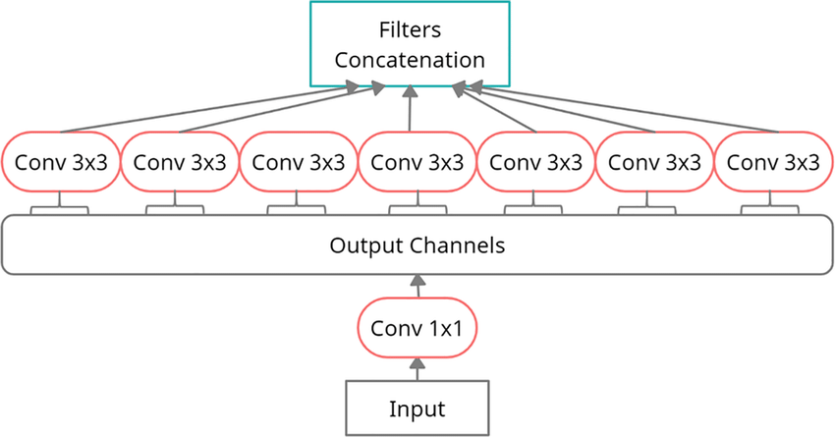

Figure. 6.

SqeezeNet Architecture
The SqueezeNet architecture is a lightweight convolutional neural network (CNN) architecture that was proposed by Forrest N. Iandola et al. in 2016. It aims to achieve high accuracy on image classification tasks while having a significantly smaller model size compared to traditional CNN architectures. The key idea behind SqueezeNet is to reduce the number of parameters in the network without sacrificing accuracy by employing several innovative design choices. The building blocks of SqueezeNet are called Fire modules. A Fire module consists of a squeeze layer and an expand layer. The squeeze layer comprises 1x1 convolutions that aim to reduce the number of input channels. This dimensionality reduction helps in compressing the network while preserving valuable information. The expand layer consists of a combination of 1x1 and 3x3 convolutions, which help in capturing both local and global context. SqueezeNet introduces two types of Fire modules: the "squeeze-and-expand" Fire module and the "expand-only" Fire module. The former has a compression ratio of 1x1, meaning it reduces the number of input channels to one-fourth. The latter has a compression ratio of 0.5x, which further reduces the number of channels by half. By using these different Fire module configurations, SqueezeNet achieves a good balance between model size reduction and preserving accuracy. SqueezeNet incorporates down sampling operations to reduce the spatial dimensions of feature maps. It uses max pooling with a stride of 2, which reduces the spatial size by half. This down sampling helps in extracting and preserving essential features while reducing computational requirements. Similar to other CNN architectures, SqueezeNet ends with fully connected layers for final classification. However, to keep the model size small, SqueezeNet uses 1x1 convolutions instead of fully connected layers. This reduces the number of parameters while achieving similar classification performance. SqueezeNet achieves a significantly smaller model size compared to traditional CNN architectures. The authors introduced techniques like parameter sharing, aggressive down sampling, and reducing 3x3 filters to 1x1 filters to compress the network. SqueezeNet has 50x fewer parameters compared to AlexNet while achieving comparable accuracy on image classification tasks. The SqueezeNet architecture is particularly suitable for scenarios with limited computational resources, such as mobile and embedded devices. It offers a good trade-off between model size and accuracy, making it efficient for real-time applications and deployments with restricted memory or processing power. Since its introduction, SqueezeNet has been used in various applications, including image classification, object detection, and semantic segmentation. It has served as a basis for further research and has inspired the development of other lightweight architectures like MobileNet and ShuffleNet. It's worth noting that while SqueezeNet provides an efficient solution for model compression, more recent architectures like EfficientNet have achieved even better trade-offs between model size and accuracy by incorporating advanced techniques like compound scaling and neural architecture search.
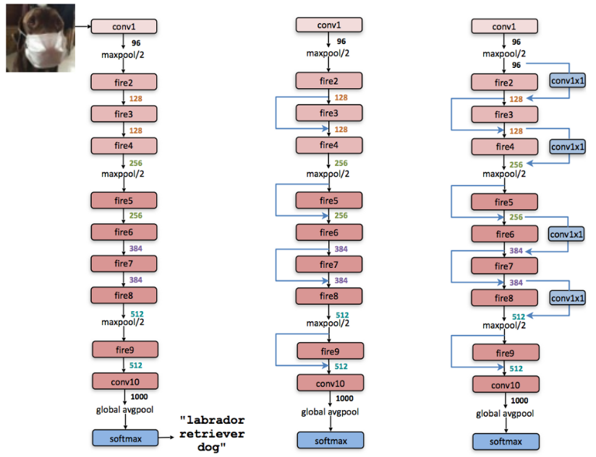

Figure. 7.

Activation Function
Activation functions play a crucial role in artificial neural networks by introducing non-linearity to the network's output. They determine whether a neuron should be activated or not based on the input it receives.
Here are some commonly used activation functions and their characteristics:
- Sigmoid Function: The sigmoid function is a smooth, S-shaped curve that maps the input to a value between 0 and 1. It is given by the formula:
σ(x) = 1 / (1 + e^(-x))
The sigmoid function is widely used in the past but has lost popularity in recent years due to some limitations. One of the main issues is the vanishing gradient problem, where gradients become very small for large inputs, making it challenging for deep networks to learn effectively. Sigmoid functions are still used in some cases, such as binary classification tasks.
- Hyperbolic Tangent (Tanh) Function: The hyperbolic tangent function is similar to the sigmoid function but maps the input to a value between -1 and 1. It is given by the formula:
tanh(x) = (e^x - e^(-x)) / (e^x + e^(-x))
Like the sigmoid function, tanh also suffers from the vanishing gradient problem. However, it has the advantage of being zero-centered, making it easier for the network to learn compared to the sigmoid function.
- Rectified Linear Unit (ReLU) Function: The ReLU function is a piecewise linear function that maps all negative input values to zero and leaves positive values unchanged. It is defined as:
ReLU(x) = max(0, x)
ReLU has gained significant popularity due to its simplicity and effectiveness in deep neural networks. It addresses the vanishing gradient problem and accelerates training by providing faster convergence. However, ReLU can also suffer from the "dying ReLU" problem, where some neurons become inactive and do not contribute to the learning process.
- Leaky ReLU Function: The Leaky ReLU function is a variant of the ReLU function that allows a small, non-zero gradient for negative inputs. It is defined as:
LeakyReLU(x) = max(ax, x)
where a is a small constant (e.g., 0.01). The non-zero gradient for negative inputs helps address the dying ReLU problem and provides better performance in some cases.
- Parametric ReLU (PReLU) Function: PReLU is another variant of the ReLU function that introduces learnable parameters. It allows the network to learn the slope of the negative part of the activation function. This enables the network to adapt the activation function to the data during training.
- Exponential Linear Unit (ELU) Function: The ELU function is a smooth approximation of the ReLU function that handles negative inputs more gracefully. It introduces a negative saturation region to allow negative values, which helps mitigate the dying ReLU problem. The ELU function is defined as:
ELU(x) = x if x > 0 = α * (e^x - 1) if x <= 0
where α is a positive constant controlling the slope of the function for negative inputs.
These are just a few examples of activation functions used in neural networks. Each activation function has its own characteristics and affects the network's learning dynamics. The choice of activation function depends on the specific problem, network architecture, and empirical performance on the task at hand.
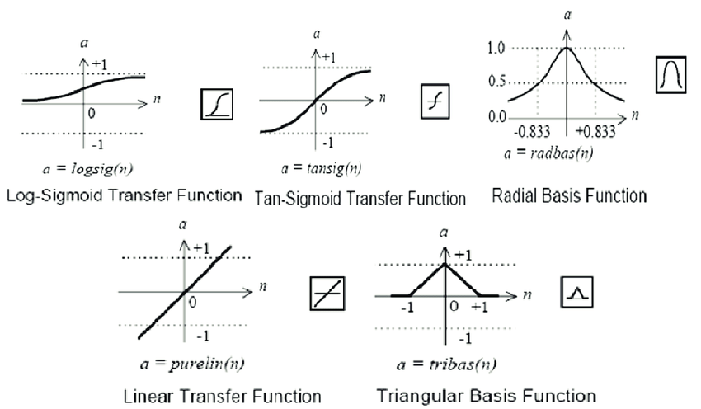

Figure. 8.

SoftMax
SoftMax is an activation function commonly used in the output layer of a neural network, particularly in multi-class classification problems. It takes a vector of real-valued inputs and transforms them into a probability distribution over multiple class. The SoftMax function operates on a vector of values, typically the logits or pre-activation outputs from the previous layer of the neural network. It exponentiates each value and normalizes them to ensure they sum up to 1. The SoftMax function can be defined as follows for a vector x:
softmax(x_i) = exp(x_i) / sum(exp(x_j)) for j in range(1, C)
where x_i represents the i-th element of the input vector, C is the total number of classes, and the sum is taken over all elements of the input vector.
The main purpose of the SoftMax function is to convert raw scores or logits into probabilities. By exponentiating the inputs and normalizing them, the SoftMax function assigns a probability to each class, indicating the likelihood of the input belonging to that class.
The SoftMax function guarantees that the resulting values sum up to 1, thereby forming a valid probability distribution. Each output value represents the probability of the input belonging to the corresponding class.
It converts the logits into probabilities, making it easier to interpret the output of the neural network. The class with the highest probability is typically selected as the predicted class. This function is differentiable, which allows for efficient backpropagation during the training process. The gradients can be computed with respect to the input logits, enabling the network to learn from the provided labels and update its weights accordingly. It amplify the differences between class probabilities, which can lead to a bias towards the class with the highest score. In scenarios with imbalanced datasets, where some classes have significantly more samples than others, this can result in poor performance. Techniques such as class weighting or utilizing alternative loss functions can help address this issue. The SoftMax function includes a temperature parameter (often denoted as T) that controls the smoothness of the output probabilities. A higher temperature value (>1) produces a softer probability distribution, while a lower temperature value (<1) produces a sharper distribution with more emphasis on the highest-scoring class. SoftMax is primarily used in multi-class classification tasks, where there are more than two mutually exclusive classes. It is often combined with the cross-entropy loss function to compute the loss and gradients during training.
While SoftMax is commonly used in the output layer for classification, it is worth noting that in some cases, alternative activation functions such as sigmoid or linear functions may be used, depending on the nature of the problem (e.g., binary classification or regression).
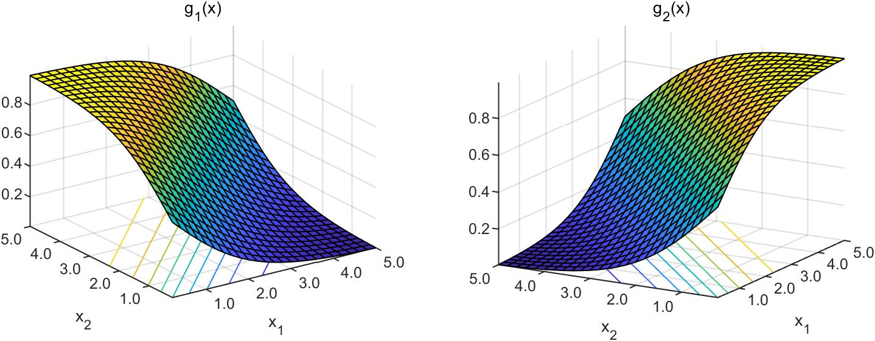
Figure. 9..

Objective
The use of an Emotion recognition system with a solid rate of accuracy is to personalize different attributes for an individual specifically to suit their interest. Consequently, we decided to do design this system where we could detect a person’s age , gender using various methods and algorithms of deep learning . for instance, A.I assistants to play music based on dedicated emotion rather than choosing randomly. Similarly, a smart car slowing down when one is angry or is in a kind of agony. As a result, this application has much potential in the world, that would benefit companies and also to even ensure safety to consumers. To enforce Convolutional Neural Networks for facial expressions and Broad ResNet framework for identifying age and gender of individual person on its glance at camera. Emotion recognition is the process of identifying a person's emotional state from various cues, such as facial expressions, physiological signals, and gestures. In recent years, emotion recognition has gained significant attention in the field of artificial intelligence (AI) and machine learning (ML). The ability to recognize emotions can help machines understand human behavior and respond appropriately. Facial expressions, age and gender determination are the most commonly used modalities for emotion recognition. While facial expressions have been studied extensively. Age and gender recognition provides rich emotional information. Therefore, it can be used as a reliable source for emotion recognition. In this article, we propose an emotion recognition system based on convolutional neural networks (CNNs) for facial expressions . CNNs are a type of deep learning model that is highly effective at image and audio processing tasks. We propose to use CNNs to recognize facial expressions from images. The proposed system has a wide range of potential applications, including personalized marketing, health monitoring, and smart homes. For instance, a personalized music player could be designed based on the user's emotion, which would automatically select music that matches the user's mood. Similarly, a smart home could be designed to adjust its lighting and temperature based on the user's emotional state. The first step in building an emotion recognition system is to collect a large dataset of labeled data. The dataset should contain a wide range of emotions and different facial expressions or speech signals The quality of the dataset is essential for the success of the system, and it should be balanced in terms of the number of samples for each emotion. For facial expression recognition, we propose to use a CNN model that is trained on the labeled dataset. The input to the CNN is an image of the face, and the output is a probability distribution over the different emotions The model is trained using back propagation, which adjusts the model parameters to minimize the error between the predicted output and the ground truth label. For predicting age and gender we use The Broad ResNet architecture is a variant of the ResNet (Residual Network) model that has wider layers to improve feature representation. It is commonly used in computer vision tasks such as age and gender identification. When using the Broad ResNet architecture for age and gender identification, the model typically takes an image as input and processes it through a series of convolutional layers, followed by pooling and fully connected layers. Here's a high-level overview of how age and gender identification can be performed using the Broad ResNet architecture.1) Input Image: The input image is fed into the Broad ResNet architecture. It is usually preprocessed by resizing and normalizing the image to a fixed size.2) Convolutional Layers: The image is passed through several convolutional layers. These layers are responsible for extracting features from the image at different spatial scales. Each convolutional layer applies a set of filters to the input image, generating feature maps that highlight different patterns and texture.3) Pooling Layers: After each set of convolutional layers, pooling layers are used to down sample the feature maps. Pooling helps reduce the spatial dimensions of the feature maps while retaining important information.4) Fully Connected Layers: The output from the last pooling layer is flattened and fed into fully connected layers. These layers are responsible for learning high-level representations of the features extracted from the image. They capture complex relationships between features and enable the model to make predictions.5) Age and Gender Prediction: The fully connected layers are connected to separate output layers for age and gender prediction. The number of nodes in the age output layer corresponds to the number of age categories or a continuous regression value. Similarly, the gender output layer has nodes representing different genders (e.g., male and female).6) Training: The model is trained using a labeled dataset where each image is annotated with its corresponding age and gender. During training, the model's parameters are adjusted using techniques like backpropagation and gradient descent to minimize the prediction error.7) Inference: After training, the model can be used for age and gender identification on unseen images. To achieve high accuracy in emotion recognition, we propose to use a deep CNN model with multiple convolutional and pooling layers. The deep model can extract high-level features from the input data, which can be used to recognize emotions accurately. One of the challenges in emotion recognition is dealing with inter-individual variability. Different people may express the same emotion differently, which can affect the accuracy of the system. To address this issue, we propose to use transfer learning, where we pretrain the CNN model on a large dataset of facial expressions or speech emotions and fine-tune it on our dataset. Transfer learning can help the model learn more general features that are not specific to a particular individual. In conclusion, we propose an emotion recognition system based on CNNs for facial expressions and speech. The proposed system has a wide range of potential applications, including personalized marketing, health monitoring, and smart homes. The system can be trained using a large labeled dataset, and the CNN model can be fine-tuned using transfer learning to improve accuracy. We believe that emotion recognition is an essential area of research in AI and has a significant potential for practical applications. Emotion detection has become an important research topic in recent years due to its wide range of applications, such as in human-computer interaction, marketing, and healthcare.

Problem Statement
Human feelings and intentions are expressed via facial expressions and speech deriving a green and powerful feature is the essential element of facial features machine. Facial expressions bring non-verbal cues, which play a crucial position in interpersonal family members. Automatic reputation of facial expressions can be an crucial thing of natural human-gadget interfaces; it could also be utilized in behavioral technological know-how and in clinical practice. An automatic Facial Expression Recognition gadget needs to clear up the subsequent problems: detection and region of faces in a cluttered scene, facial function extraction, and facial features classification.

Methodologies

The primary idea of the project is to recognize emotion and predict age and gender using various methods and algorithms of deep learning. For age-gender classification, the dataset was obtained from IMDb-WIKI, and for emotion detection, it was obtained from Kaggle's Fer2013 dataset. Two models are used in this design: one is trained to predict age and gender using a broad ResNet framework, while the other is taught to recognize emotions using a traditional CNN architecture. Compared to classifier-based approaches, our technique exhibits higher classification accuracy for both age and gender.

Background
Recognizing age, gender, and facial expressions from images or videos is a challenging task in computer vision and pattern recognition. It involves developing algorithms and models that can automatically analyze visual cues to infer specific attributes related to age, gender, and emotional expressions. Age Recognition aims to estimate the age of a person from visual cues, such as facial appearance or other relevant features. It is a complex task because age estimation is subjective and can vary across different cultures and individuals. Factors such as wrinkles, facial contours, hair color, and skin texture are typically considered in age estimation algorithms. Machine learning techniques, including deep learning models like convolutional neural networks (CNNs), have been widely used for age recognition due to their ability to capture intricate facial features. Gender Recognition focuses on determining the gender of a person based on visual characteristics. It involves analyzing facial attributes such as facial structure, hair length, and other gender-specific features. Similar to age recognition, deep learning models, particularly CNNs, have shown promising results in gender recognition tasks. These models are trained on large-scale datasets containing labeled images of individuals, allowing them to learn discriminative patterns and features indicative of gender. Facial Expression Recognition aims to detect and classify various emotional states displayed by a person's face. It involves analyzing facial muscle movements and their configurations to infer emotions such as happiness, sadness, anger, disgust, fear, and surprise. Traditional approaches to facial expression recognition include extracting handcrafted features like facial landmarks or texture descriptors and using machine learning algorithms for classification. However, deep learning methods, particularly CNNs and recurrent neural networks (RNNs), have demonstrated significant advancements in facial expression recognition by directly learning expressive features from raw facial images or sequences. To train models for age, gender, and facial expression recognition, large annotated datasets are crucial. Researchers and organizations have created labeled datasets, such as the Audience dataset for age and gender recognition and the Extended Cohn-Kanade (CK+) dataset for facial expression recognition. These datasets provide diverse samples of individuals across different ages, genders, and emotional expressions, facilitating the development and evaluation of robust recognition models. In recent years, advancements in deep learning, increased computational power, and the availability of large-scale datasets have significantly improved the performance of age, gender, and facial expression recognition systems. These technologies have applications in areas such as biometrics, human-computer interaction, marketing, and surveillance, offering valuable insights and enabling various practical use cases.

Optimizer

In the context of deep learning, an optimizer is an algorithm or method used to adjust the weights of a neural network during the training process. The goal of an optimizer is to minimize the loss function and find the set of weights that result in the best performance of the model on the given task. Optimizers play a crucial role in determining the speed and quality of convergence during training.

Here are some commonly used optimizers in deep learning:

Stochastic Gradient Descent (SGD): SGD is the basic and most widely used optimizer in deep learning. It updates the weights in the opposite direction of the gradient of the loss function with respect to the weights. The update rule for SGD is given by:

W_new = W_old - learning_rate * gradient

where W_new and W_old are the new and old weight values, respectively, learning_rate is a hyperparameter controlling the step size of the update, and the gradient represents the derivative of the loss function with respect to the weights.

Momentum: Momentum is an extension of SGD that introduces a momentum term to accelerate the convergence and overcome the issue of oscillations in the gradient path. It adds a fraction of the previous weight update to the current update, allowing the optimizer to move more consistently towards the minimum. The update rule for momentum is given by:

V_new = momentum * V_old - learning_rate * gradient W_new = W_old + V_new

where V_new and V_old represent the updated and previous velocity, respectively, momentum is a hyperparameter controlling the contribution of the previous update, and the other variables have the same meaning as in SGD.

AdaGrad: AdaGrad adapts the learning rate for each weight individually based on the historical gradients. It increases the learning rate for infrequent features and decreases it for frequent features. This helps the optimizer converge quickly in directions with steep gradients and more slowly in flatter directions. The update rule for AdaGrad is given by:

G_new = G_old + gradient^2 W_new = W_old - (learning_rate / sqrt(G_new + epsilon)) * gradient

where G_new and G_old represent the updated and previous squared gradients, respectively, epsilon is a small constant added for numerical stability, and the other variables have the same meaning as in SGD.

RMSprop: RMSprop is an extension of AdaGrad that addresses its aggressive and monotonically decreasing learning rate. It introduces a decay term that limits the accumulation of historical gradients. The update rule for RMSprop is given by:

G_new = decay * G_old + (1 - decay) * gradient^2 W_new = W_old - (learning_rate / sqrt(G_new + epsilon)) * gradient

where G_new and G_old represent the updated and previous squared gradients, respectively, decay is a hyperparameter controlling the contribution of the previous gradients, and the other variables have the same meaning as in AdaGrad.

Adam: Adam combines the benefits of both momentum and RMSprop. It utilizes adaptive learning rates for each weight and also includes a momentum-like term. Adam has become one of the most popular and widely used optimizers in deep learning. The update rule for Adam is given by:

M_new = beta1 * M_old + (1 - beta1) * gradient V_new = beta2 * V_old + (1 - beta2) * gradient^2 W_new = W_old - (learning_rate / (sqrt(V_new) + epsilon)) * M_new

where M_new and M_old represent the updated and previous first moments (mean), V_new and V_old represent the updated and previous second moments (uncentered

variance), beta1 and beta2

Adam Optimizer
Adam (Adaptive Moment Estimation) optimizer is an adaptive learning rate optimization algorithm commonly used in deep learning. It combines the concepts of momentum-based optimization and root mean square (RMS) propagation to achieve efficient and effective parameter updates during training.
Here's a detailed explanation of the Adam optimizer:
- Gradient-Based Optimization: Adam optimizer, like other gradient-based optimization algorithms, aims to minimize the loss function by iteratively updating the model parameters based on the gradients of the loss with respect to the parameters.
- Momentum-Based Optimization: Adam incorporates the concept of momentum, which helps accelerate the convergence and overcome local minima. It utilizes a running average of the gradients' first moment (mean) to keep track of the direction of the previous gradients.
- RMS Propagation: In addition to momentum, Adam uses RMS propagation to adjust the learning rate for each parameter individually. It maintains a running average of the gradients' second moment (variance) to adaptively scale the learning rate.
- Parameter Initialization: Adam initializes two variables, namely the first moment estimate (m) and the second moment estimate (v), to zero vectors of the same size as the parameters being optimized.
- Update Rule: At each iteration, Adam calculates the current gradient of the parameters and updates the estimates of the first and second moments using exponential decay rates, beta1 and beta2, respectively. These decay rates control the contribution of past gradients to the current estimates.
- Bias Correction: To account for the bias introduced by initializing the first and second moment estimates to zero, Adam performs bias correction by adjusting the estimates in the early iterations. This correction is necessary to make the initial updates more accurate.
- Learning Rate: Adam adapts the learning rate for each parameter based on the estimates of the first and second moments. The learning rate is dynamically scaled based on the ratio of the current gradient to the magnitude of the previous gradients.
- Regularization: Adam supports L2 regularization by incorporating the L2 penalty term into the parameter updates. This helps prevent overfitting by encouraging smaller weights in the model.
Benefits of Adam optimizer:
- Efficient updates: The adaptive learning rate of Adam allows for efficient parameter updates, especially in high-dimensional spaces.
- Robustness to noisy gradients: The running averages of the first and second moments help reduce the impact of noisy gradients during training.
- Little manual tuning: Adam adjusts the learning rate automatically, reducing the need for manual tuning of hyperparameters.
However, it's worth noting that Adam may not always be the optimal choice for all scenarios. In some cases, other optimization algorithms such as SGD (Stochastic Gradient Descent) or its variants may perform better, particularly with smaller datasets or certain network architectures.
In practice, it is common to use Adam as a default optimizer choice for deep learning tasks due to its overall effectiveness and ease of use. It has become a popular choice among researchers and practitioners for a wide range of applications.

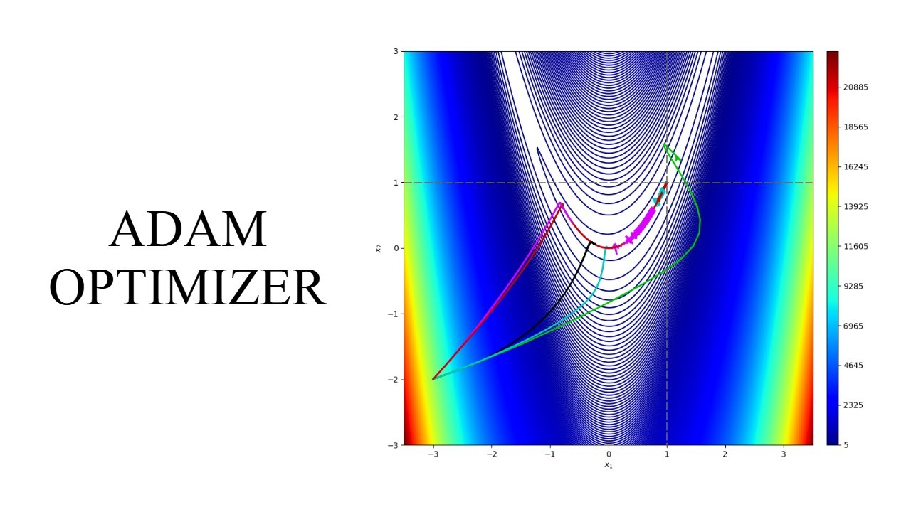
Figure. 10.

Weight
In the context of deep learning, weights refer to the learnable parameters of a neural network. They represent the strengths of connections between neurons in different layers of the network. The weights determine how input data is transformed as it passes through the network, allowing the network to learn and make predictions.
Here are some key points about weights in deep learning:
- Initialization: Initially, the weights of a neural network are initialized randomly. Proper initialization is crucial because it helps the network converge faster during training. Common weight initialization techniques include random initialization from a uniform or Gaussian distribution, Xavier initialization, and He initialization, which take into account the dimensions of the weight matrices and the activation functions used.
- Learnable Parameters: During training, the weights are adjusted to minimize the difference between the predicted output of the network and the true target values. This is done through the process of backpropagation, where gradients are computed with respect to the weights using the chain rule of derivatives. The weights are updated in the direction that minimizes the loss function using optimization algorithms like gradient descent, Adam, or RMSprop.
- Weight Sharing: In some cases, weight sharing is employed to reduce the number of parameters and improve the efficiency of the network. Weight sharing refers to using the same set of weights for multiple connections in the network. This is commonly seen in convolutional neural networks (CNNs) where the same filters are applied to different regions of the input image.
- Regularization: Regularization techniques are often applied to prevent overfitting, which occurs when the model learns to perform well on the training data but fails to generalize to new data. Regularization methods like L1 and L2 regularization, dropout, and batch normalization help control the magnitudes of the weights and improve the network's generalization ability.
- Importance in Model Performance: The weights play a crucial role in determining the performance of the deep learning model. Proper adjustment of weights allows the network to learn meaningful representations from the input data, capture complex patterns, and make accurate predictions. Well-tuned weights result in improved accuracy and generalization capability.
- Transfer Learning: Pre-trained weights from a previously trained model can be used as a starting point for a new model or a different task. This is known as transfer learning and is effective when the new task has limited labeled data. By utilizing pre-trained weights, the network can benefit from the learned representations and potentially achieve better performance with less training.
It's important to note that the weights in a deep learning model are updated iteratively during training, and the learning process aims to find the optimal values that minimize the loss function. Proper weight initialization, regularization, and optimization techniques are critical for training deep learning models effectively and achieving good performance on the given task
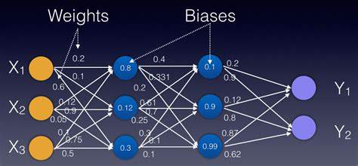

Figure. 11.

Loss Function
Loss functions, also known as cost functions or objective functions, are an integral part of deep learning models. They quantify the discrepancy between the predicted output of a model and the true target values. The choice of a suitable loss function depends on the specific task and the desired properties of the model.
Here are some commonly used loss functions in deep learning:
- Mean Squared Error (MSE) Loss: The MSE loss is widely used in regression problems, where the goal is to predict continuous values. It measures the average squared difference between the predicted and true values. The formula for MSE is:
MSE = (1/n) * Σ(y_pred - y_true)^2
where y_pred is the predicted value, y_true is the true value, and n is the number of samples.
- Binary Cross-Entropy Loss: Binary cross-entropy loss is commonly used in binary classification problems, where there are two mutually exclusive classes. It calculates the cross-entropy between the predicted probabilities and the true binary labels. The formula for binary cross-entropy is:
BCE = - (y_true * log(y_pred) + (1 - y_true) * log(1 - y_pred))
where y_pred is the predicted probability, y_true is the true label (0 or 1).
- Categorical Cross-Entropy Loss: Categorical cross-entropy loss is used in multi-class classification problems, where there are more than two mutually exclusive classes. It measures the dissimilarity between the predicted class probabilities and the true class labels. The formula for categorical cross-entropy is:
CCE = - Σ(y_true * log(y_pred))
where y_pred is the predicted probability vector, y_true is the true one-hot encoded label vector.
- Sparse Categorical Cross-Entropy Loss: Sparse categorical cross-entropy loss is similar to categorical cross-entropy, but it is used when the true labels are provided as integers rather than one-hot encoded vectors. This is commonly used in scenarios where the number of classes is large and encoding all labels as one-hot vectors would be memory-intensive.
- Kullback-Leibler Divergence (KL Divergence) Loss: KL divergence loss measures the difference between two probability distributions. It is often used in scenarios such as variational autoencoders (VAEs) or generative adversarial networks (GANs) to compare the similarity between the generated samples and the true data distribution.
- Huber Loss: Huber loss is a robust loss function that is less sensitive to outliers compared to the mean squared error. It combines quadratic and linear loss functions, providing a balance between the two. It is often used in regression tasks where the presence of outliers can significantly impact the performance.
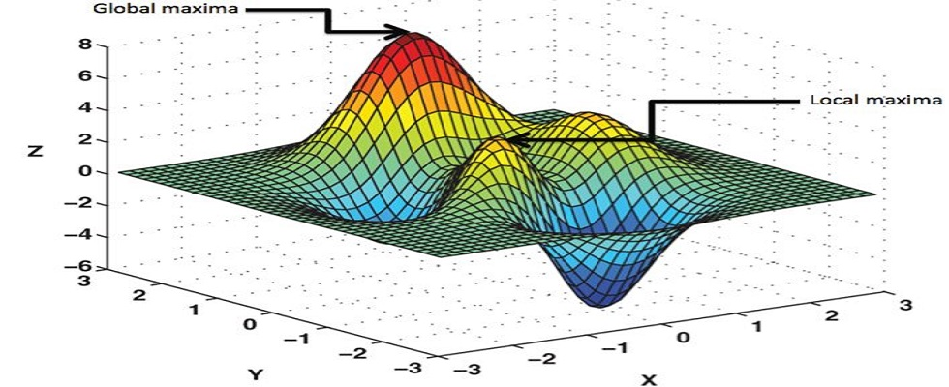
These are just a few examples of loss functions commonly used in deep learning. The choice of a loss function depends on the problem at hand, the nature of the data, and the desired properties of the model. It is important to select a loss function that aligns with the specific requirements and objectives of the task to optimize the model effectively during training.

Figure. 12.

DropOut Layer

Dropout is a regularization technique commonly used in deep learning models to prevent overfitting. It involves randomly dropping out (setting to zero) a fraction of the input units or neurons during the training phase. This forces the network to learn more robust and generalized representations by reducing the reliance on any single subset of neurons.

Here are the key details about dropout layers:

Purpose: The primary purpose of dropout is to improve the generalization ability of deep learning models. By randomly dropping out neurons, dropout prevents co-adaptation of neurons, where specific neurons become overly dependent on each other for making predictions. This encourages the network to learn more independent and diverse features, making it more robust to noise and variations in the input data.

Implementation: Dropout is typically implemented as a separate layer in the neural network architecture, placed between the fully connected layers or convolutional layers. During training, each neuron in the dropout layer has a probability (dropout rate) of being temporarily "dropped out" or deactivated. The dropout rate is a hyperparameter that determines the fraction of neurons to be dropped, typically ranging from 0.2 to 0.5.

Inference Phase: During the inference phase or when making predictions, dropout is usually turned off, and all neurons are used. However, the weights of the neurons are scaled by the inverse of the dropout rate to maintain the expected activation level. This scaling ensures that the predictions made during inference are consistent with the expected output of the network.

Regularization Effect: Dropout acts as a regularization technique by introducing noise or randomness into the network during training. By dropping out neurons, dropout effectively reduces the model's capacity, preventing it from overfitting to the training data. This regularization effect helps improve the model's ability to generalize to unseen data, resulting in better performance on test or validation sets.

Training Time and Model Ensemble: Dropout increases the computational cost during training because each forward pass requires randomly dropping out neurons. However, it also provides a form of model ensemble during training. Since different subsets of neurons are dropped out in each training iteration, the network effectively trains multiple subnetworks, which can be seen as an ensemble of models. This ensemble effect improves the robustness and stability of the learned representations.

Hyperparameter Tuning: The dropout rate is a hyperparameter that needs to be tuned during model development. A dropout rate that is too low may not provide enough regularization, leading to overfitting, while a dropout rate that is too high may result in underfitting. The optimal dropout rate depends on the specific task, dataset, and model architecture. It is typically determined through experimentation and cross-validation.

Overall, dropout is a powerful regularization technique in deep learning that helps prevent overfitting, improve generalization, and increase the robustness of the learned representations. It is widely used in various types of neural networks, including fully connected networks, convolutional neural networks (CNNs), and recurrent neural networks (RNNs).
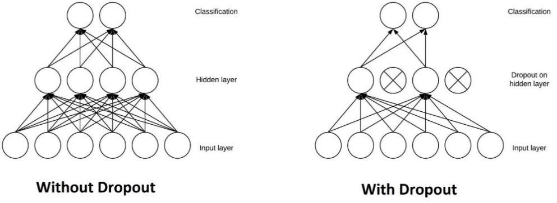

Figure. 13.

1.5 Structure of the report
The entire report can be divided into three broad sections that are mentioned below:

- Pre-factory information
  - Title Page
    - This includes the report’s title, name, and address of the organization conducting the research.
    - The name of the client to whom the report is to be submitted.
    - And the date of submission
  - Declaration
    - It states that the project group has submitted the results of their own thought, research, or self-expression and there is no plagiarism.
  - Certificate
    - The certificate states that the work has been carried out by this project group and has not been submitted by any other project group of the institute for award or degree.
  - Acknowledgements
    - Acknowledgments provide a way to thank those who supported or encouraged you in research, writing, and other parts of developing reports and papers.
  - Table of Contents
    - This covers the list of all the topics with their page numbers.
  - Abstract
    - It is a very important part of this section which summarizes the problem, research design, and the major findings and conclusions.
    - It is like a mini report.
- Main body
  - Introduction
    - This chapter discusses the introduction, motivation, and need for a project in the real world.
  - Literature Survey
    - This section discusses all the past research work related to the field in which the project has been made and mentions the work, shortcomings, improvements, etc. of past research works.
  - Fundamentals of Project
    - This Section Discusses the project made by team members including working, basics, implementation, designing, etc.
  - Results and Discussion

- Pre-factory information
  - Title Page
    - This includes the report’s title, name, and address of the organization conducting the research.
    - The name of the client to whom the report is to be submitted.
    - And the date of submission
  - Declaration
    - It states that the project group has submitted the results of their own thought, research, or self-expression and there is no plagiarism.
  - Certificate
    - The certificate states that the work has been carried out by this project group and has not been submitted by any other project group of the institute for award or degree.
  - Acknowledgements
    - Acknowledgments provide a way to thank those who supported or encouraged you in research, writing, and other parts of developing reports and papers.
  - Table of Contents
    - This covers the list of all the topics with their page numbers.
  - Abstract
    - It is a very important part of this section which summarizes the problem, research design, and the major findings and conclusions.
    - It is like a mini report.

- Pre-factory information
  - Title Page
    - This includes the report’s title, name, and address of the organization conducting the research.
    - The name of the client to whom the report is to be submitted.
    - And the date of submission
  - Declaration
    - It states that the project group has submitted the results of their own thought, research, or self-expression and there is no plagiarism.
  - Certificate
    - The certificate states that the work has been carried out by this project group and has not been submitted by any other project group of the institute for award or degree.
  - Acknowledgements
    - Acknowledgments provide a way to thank those who supported or encouraged you in research, writing, and other parts of developing reports and papers.
  - Table of Contents
    - This covers the list of all the topics with their page numbers.
  - Abstract
    - It is a very important part of this section which summarizes the problem, research design, and the major findings and conclusions.
    - It is like a mini report.
- Main body
  - Introduction
    - This chapter discusses the introduction, motivation, and need for a project in the real world.
  - Literature Survey
    - This section discusses all the past research work related to the field in which the project has been made and mentions the work, shortcomings, improvements, etc. of past research works.
  - Fundamentals of Project
    - This Section Discusses the project made by team members including working, basics, implementation, designing, etc.
  - Results and Discussion

    - This section discusses the conclusions and research papers published while making the project.
  - Conclusions and Further Works
    - This section interprets the conclusion and further work that need to be done.
- End section
  - References
    - A reference documents the sources used by researchers in writing the report in alphabetic order.
  - List of Publications
    - It contains a list of all the research papers that the researchers have published in the course of their study.
  - Certificates
    - These contains certificates that the researchers have got for their research papers in the course of their study.

CHAPTER 2

LITREATURE SURVEY

- Deep learning for sentiment analysis: A survey" by Lei Zhang et al. (2018) This paper provides a comprehensive survey of deep learning techniques used for sentiment analysis. The authors discuss various neural network architectures, such as convolutional neural networks (CNNs), recurrent neural networks (RNNs), and their variants, that have been applied to sentiment analysis. The paper also covers transfer learning and multi-task learning techniques used for sentiment analysis. The authors conclude that deep learning techniques have achieved state-of-the-art results in sentiment analysis and have the potential to improve in the future.

- Emotion recognition using facial landmarks, Python, DLib and OpenCV" by Marcin Pietranik (2018) In this paper, the author proposes a method for emotion detection using facial landmarks detected using Python, DLib, and OpenCV. The author uses a convolutional neural network (CNN) to classify the emotions based on the facial landmarks. The results show that the proposed method achieves an accuracy of 91.4% on the CK+ dataset and 84.8% on the JAFFE dataset, which are both widely used datasets for emotion detection.

- Deep learning-based emotion recognition from speech signals" by B. Yegnanarayana et al. (2019) This paper proposes a deep learning-based approach for emotion detection from speech signals. The authors use a combination of convolutional neural networks (CNNs) and long short-term memory (LSTM) networks to learn the features from speech signals. The proposed method achieves an accuracy of 65.33% on the IEMOCAP dataset, which is a benchmark dataset for emotion detection from speech signals.

- Sentiment analysis using deep learning techniques: A review" by I. A. H. Akhtar et al. (2020) This paper provides a review of deep learning techniques used for
sentiment analysis. The authors discuss various deep learning architectures, such as CNNs, RNNs, and their variants, that have been applied to sentiment analysis. The paper also covers transfer learning and multi-task learning techniques used for sentiment analysis. The authors conclude that deep learning techniques have achieved state-of-the-art results in sentiment analysis and have the potential to improve in the future.

- Emotion recognition using deep learning techniques: A review" by V. P. Desai et al. (2021) This paper provides a review of deep learning techniques used for emotion recognition. The authors discuss various deep learning architectures, such as CNNs, RNNs, and their variants, that have been applied to emotion recognition. The paper also covers transfer learning and multi-task learning techniques used for emotion recognition. The authors conclude that deep learning techniques have shown promising results in emotion recognition tasks and have the potential to improve in the future.

- "Deep Learning Face Attributes in the Wild" (2015) by Rui Li et al. (2015) This paper proposes Li et al. proposed a deep learning framework for age and gender estimation from face images. They combined a multi-column deep neural network architecture with multi-task learning to jointly predict age and gender.

- Deep Learning-Based Facial Expression Recognition: A Comprehensive Review Facial expression recognition (FER) is one of the most commonly used methods for emotion detection. This paper provides a comprehensive review of deep learning- based FER methods. It discusses various deep learning architectures used for FER, such as Convolutional Neural Networks (CNNs), Recurrent Neural Networks (RNNs), and Hybrid models. The paper also reviews various datasets used for FER and compares the performance of different deep learning models on these datasets. The review concludes with some future research directions for FER using deep learning.

- Deep Emotion Recognition Using Convolutional Neural Networks This paper proposes a deep learning-based method for emotion recognition using CNNs. The
- proposed method first extracts facial features using a pre-trained CNN and then feeds these features into a fully connected neural network for classification. The authors evaluate their method on two benchmark datasets, achieving state-of-the-art performance on both. The paper also provides a comparative analysis of their method with other state-of-the-art methods and demonstrates the effectiveness of their approach.

- "Deep Age and Gender Estimation Based on Convolutional Neural Network"by Yang Yang et al.(2017) : Yang et al. proposed a deep age and gender estimation model based on the VGGNet architecture. They introduced a novel feature fusion approach and achieved state-of-the-art performance on several benchmark datasets.

- "Age and Gender Classification Using Convolutional Neural Networks" (2015)by Gil Levi and Tal Hassner: Levi and Hassner developed a deep convolutional neural network model for estimating age and gender from face images. They introduced a residual-based architecture and trained the model on a large-scale dataset.

- Affective Computing: A Survey of Recent Trends, Challenges, and Applications Affective computing is an interdisciplinary field that focuses on developing computational methods for recognizing, interpreting, and expressing emotions. This survey paper provides an overview of recent trends, challenges, and applications in affective computing. The authors discuss various approaches used in affective computing, such as physiological signal-based methods, facial expression recognition, and speech emotion recognition. The paper also reviews various applications of affective computing, such as healthcare, education, and entertainment. The survey concludes with some future research directions for affective computing the result to achieve our desire goal in this

CHAPTER 3
PROJECT DESCRIPTION AND GOALS

Our project's motto is to develop an Emotion recognition system, which can recognize any test subject’s emotion almost accurately in any kind of situation. For this design the two major components are Most prominent feature selection. Most accurate classification algorithm to simulate accurate results based on the features extracted.

Proposed Methodology

The hierarchical approach is used to determine the age, gender, and emotion of a person in front of a camera. The first step involves using YOLOv2-tiny (You Only Look Once) to detect the face of the individual. The resulting image frames are then passed through several deep neural networks that have been trained on publicly available datasets. The process includes two modules: one for emotion detection and another for age and gender identification. The emotion module receives input from YOLOv2-tiny's output and uses various hidden neural networks to map the facial characteristics onto the input image. The output is produced using a SoftMax layer. The age-gender module receives the output from the emotion module and stores it in an HDF5 file. The final output is a combination of both modules and displays the age, gender, and emotion of the input data.
The model uses a webcam and OpenCV to capture frames and initially uses YOLOv2-tiny to detect the face of the person in front of the camera. YOLOv2-tiny is a real-time object detection tool. The network architecture comprises several deep neural networks, and each frame is sent as input to this architecture. The Conv2D layer receives the input image first, and the resulting output is fed into MaxPool 2D. The other hidden layers extract facial features and carry them forward. The output of the emotion model is passed to the age-gender module via an HDF5 file. This input goes through several hidden layers to extract features from the face before being passed to global average pooling 2D, which computes the average value of all values. The SoftMax layer then creates the final integrated result of both modules and displays the age, gender, and emotion of the input data.
Based on the research of related works and the objectives of the project, the following goals are to be achieved:
- to analyze each dataset via rigorous exploration
- to successfully extract feature subsets via feature selection
- to perform classification using the five different algorithms on each subset
- to construct an efficient CNN architecture
- to perform classification of the subsets using the constructed CNN

System Architecture
Convolution Neural Networks (CNN’s) are used to differentiate the speech samples based on their emotion. Databases inclusive of RAVDEES and SAVEE are applied to prepare and determine CNN fashions. Keras (Tensor Flow’s high- degree API for building and training deep gaining knowledge of models) is used as the programming framework to put in force CNN fashions. Seven exploratory arrangements of the present work are explained in this section.

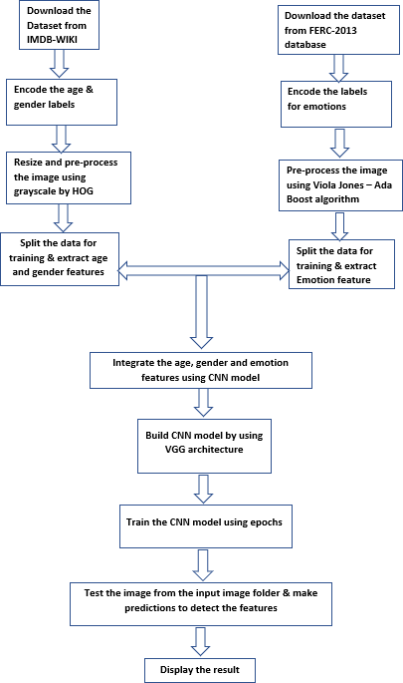
FIGURE 2.2.1 SYSTEM ARCHITECTURE

Figure. 14.

YOLO
YOLO (You Only Look Once) is a state-of-the-art object detection algorithm introduced by Joseph Redmon et al. in 2015. It revolutionized real-time object detection by combining high accuracy and impressive speed in a single framework. YOLO takes an input image and directly predicts the bounding boxes and class probabilities of multiple objects within the image.
Here's a detailed explanation of YOLO:
- Grid-based Detection: YOLO divides the input image into a grid of cells. Each cell is responsible for predicting bounding boxes and class probabilities for objects that fall within it. The size of the grid can be adjusted based on the desired level of granularity in object detection.
- Single Forward Pass: Unlike traditional object detection algorithms that rely on multiple stages or region proposals, YOLO performs object detection in a single forward pass of a convolutional neural network (CNN). This enables YOLO to achieve real-time inference speeds.
- Anchor Boxes: YOLO uses anchor boxes to predict bounding boxes. Anchor boxes are pre-defined boxes of different sizes and aspect ratios. YOLO predicts the offsets (i.e., shifts) from anchor boxes to adjust them to match the shape and size of the actual objects in the image.
- Prediction Encoding: Each grid cell in YOLO predicts multiple bounding boxes and their associated class probabilities. For each bounding box, YOLO predicts the x and y coordinates, width and height, confidence score, and class probabilities. The confidence score reflects the likelihood of an object being present in the bounding box, and the class probabilities represent the probability of the object belonging to different predefined classes.
- Non-Maximum Suppression: After the predictions are generated, YOLO applies non-maximum suppression to eliminate duplicate and overlapping bounding boxes. Non-maximum suppression selects the bounding box with the highest confidence score and suppresses overlapping boxes with lower scores, resulting in a final set of non-overlapping and highly confident bounding boxes.
- Training: YOLO is trained on labeled datasets, where each image is annotated with bounding box coordinates and class labels. During training, YOLO uses a loss function that combines localization loss (how well the predicted bounding box aligns with the ground truth) and classification loss (how well the predicted class probabilities match the ground truth). The network is then optimized using techniques like backpropagation and gradient descent to minimize the loss.
- YOLO Variants: Since its introduction, YOLO has undergone several improvements and variations. YOLOv2 introduced architectural changes like anchor boxes and feature pyramid networks for better accuracy and multi-scale object detection. YOLOv3 further improved upon YOLOv2 with the addition of more layers, larger input size options, and improved feature extraction. YOLOv4 and YOLOv5 continued to refine the architecture with advancements in network design, data augmentation, and training strategies.
YOLO has become a popular choice for real-time object detection applications due to its impressive performance and speed. It has been successfully used in various domains, including autonomous driving, surveillance, robotics, and more. The continuous development of YOLO and its variants has pushed the boundaries of real-time object detection and significantly contributed to the field of computer vision.
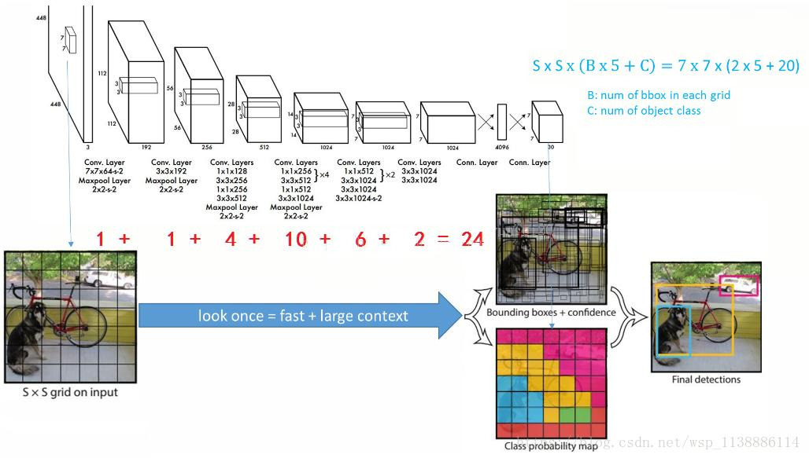

- Figure. 15.

Datasets Of Age, gender Recognition

The IMDb-WIKI dataset is a widely used and publicly available dataset extensively used in age estimation and face recognition research. It is composed of face images collected from IMDb (Internet Movie Database) and Wikipedia. This dataset has become a standard benchmark for training and evaluating models for age estimation, gender classification, and related tasks. The dataset was compiled by gathering images of celebrities from IMDb, which offers an extensive database of actors and actresses, and from Wikipedia, which includes a diverse range of individuals from various fields. The dataset contains age annotations for a substantial number of images, obtained from publicly available information like birthdates mentioned on IMDb or Wikipedia pages. With its wide variety of images, including professional headshots and casual photographs, the dataset captures different lighting conditions, facial expressions, and poses, enabling the training of models robust to real-world variations. The dataset is typically split into training, validation, and testing subsets, facilitating model development, hyperparameter tuning, and final evaluation. While the dataset offers rich face images for age and gender analysis, it does come with some challenges. Age annotations may not always be precise, which can introduce potential inaccuracies in the dataset. Moreover, the dataset primarily focuses on celebrities, which might limit its representation of the general population. Nonetheless, due to its availability and comprehensive nature, the IMDb-WIKI dataset has been widely used in various research studies to develop and evaluate age estimation and gender classification algorithms.

Feature Extraction
The proposed method based on the Broad ResNet architecture extracts key features from facial images for age and gender recognition. By leveraging deep convolutional layers, the model captures intricate details such as edges, textures, and facial landmarks, along with higher-level characteristics like expressions and facial structures. The extension of the architecture with broader convolutional filters enhances the model's ability to capture global information and context in the images, contributing to a more comprehensive representation of facial features. Additionally, the increased model capacity allows for the extraction of rich and complex features that are crucial for accurate age and gender recognition. Through training on large-scale datasets like IMDb-WIKI, the model learns robust features that generalize well to unseen facial images, resulting in improved performance. By utilizing these extracted features, the proposed approach demonstrates its effectiveness in age and gender classification tasks, leveraging the power of deep convolutional networks and the advantages offered by the Broad ResNet architecture.

Haar-Cascade Classifier

Haar Cascade Classifier is a machine learning-based object detection algorithm developed by Viola and Jones in 2001. It is particularly well-known for its application in face detection but can also be used to detect other objects of interest.
The algorithm is based on the Haar-like features, which are simple rectangular features that are calculated by subtracting the sum of pixel intensities in one region from the sum of pixel intensities in another region. These Haar-like features are computed at different scales and positions across an image.
The Haar Cascade Classifier consists of two main stages: training and detection.
- Training:
  - Positive Samples: Positive samples refer to the images containing the objects of interest, such as faces. These images are labeled to indicate the presence of the object.
  - Negative Samples: Negative samples refer to images that do not contain the objects of interest. These images are labeled as background.
  - Feature Selection: During the training process, a large number of Haar-like features are computed on both positive and negative samples. The algorithm selects a small subset of discriminative features that are most effective in distinguishing the object from the background.
  - AdaBoost: AdaBoost (Adaptive Boosting) is used to iteratively select the best features and create a strong classifier. Each feature is assigned a weight based on its performance in classifying the positive and negative samples. The weights are adjusted at each iteration to focus on misclassified samples, allowing the classifier to improve over time.
  - Cascade Classifiers: Multiple weak classifiers are combined into a strong classifier using a cascade structure. Each weak classifier is trained using a subset of features, and the cascade structure allows for efficient and fast detection by quickly rejecting regions that are unlikely to contain the object.
- Detection:
  - Sliding Window: The detection process involves scanning a sliding window across the input image at different scales and positions. The window size is varied to account for different object sizes.
  - Integral Image: To efficiently compute the Haar-like features, an integral image representation is used. The integral image allows for the fast calculation of rectangular feature sums by storing the cumulative sum of pixel intensities.
  - Adaboost Classification: At each sliding window position, the computed Haar-like features are evaluated using the trained AdaBoost classifier. The classifier determines whether the window contains the object or not based on the learned weights of the selected features.
  - Cascade Classification: The cascade structure is utilized to speed up the detection process. The image regions that pass through the early stages of the cascade (which consists of fewer and faster classifiers) are further evaluated by subsequent stages with more complex classifiers. This allows for early rejection of regions that are unlikely to contain the object, reducing the number of computations needed.
  - Non-Maximum Suppression: After the cascade classifiers have been applied, a post-processing step called non-maximum suppression is performed to eliminate duplicate detections and select the most accurate bounding boxes for the detected objects.
Haar Cascade Classifier has been widely used for real-time object detection tasks due to its efficiency and accuracy. While it was originally designed for face detection, it has been successfully applied to detect various objects, including eyes, pedestrians, and vehicles. However, one limitation of the Haar Cascade Classifier is that it may struggle with complex object appearances or variations in scale, pose, or lighting conditions. Other more advanced object detection algorithms, such as Faster R-CNN and YOLO, have since been developed to address these limitations.

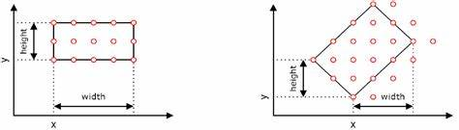

Figure. 16.

Designing the Dimensions of the Model
When designing the dimensions of the model based on the Broad ResNet architecture for age and gender recognition, several considerations come into play. Firstly, the depth of the model, which refers to the number of convolutional layers and residual blocks, needs to strike a balance between model complexity and computational resources. The selection of filter sizes is another crucial aspect, with smaller filter sizes often used in initial layers and larger ones in subsequent layers to capture both local details and global context. Network width, determined by the number of filters in each layer, should be carefully chosen to balance model capacity and computational efficiency. Incorporating pooling and striding operations can help reduce spatial dimensions and increase the receptive field. Lastly, the addition of fully connected layers can transform the extracted features into age and gender predictions. Regularization techniques like dropout and batch normalization can be incorporated to prevent overfitting. It's important to experiment and fine-tune these design choices based on dataset characteristics, computational constraints, and desired performance, as specific adjustments may be needed for optimal results

Model Training and Testing
The model is trained with the training dataset and tested with the test data set. Actual values are compared with the predicted values. This comparison gives us the accuracy of the model. The dataset is split into training and validation sets for model training and evaluation. A CNN deep learning algorithm is used for age and gender prediction and emotion recognition to get a high accuracy The architecture of the model is designed , including the number of layers, their types (e.g., convolutional, recurrent), activation functions, and connections. The model is trained using the extracted features as input and the corresponding labels for age, gender, and emotions. Optimize hyperparameters, such as learning rate, batch size, and regularization techniques, to improve the model's performance. The model's performance is evaluated using appropriate metrics, such as accuracy, precision, recall, or F1 score, on the validation set. Adjust the model architecture and hyperparameters as needed.

Architecture of Cnn
In the current study, the deep neural network architecture actualized is convolutional neural network. In the proposed architecture after each convolutional layer max-pooling layer is placed. To establish non linearity in the model, for activation function Rectified Linear Units (ReLU) is used in both convolutional and fully connected layers.
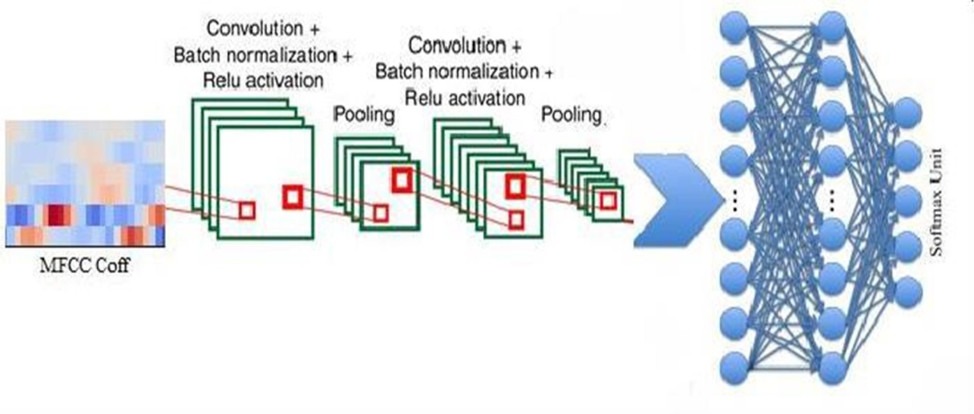
Figure. 17.
Batch normalization is used to improve the firmness of neural network, which normalizes the result of the preceding activation layer by reducing the number by what the hidden unit values move around and allows each of the layers in a network to learn by itself. Dense layer is used; in which all the neurons in a layer are connected to neurons in the next layer and it is a fully connected layer. Softmax unit is used to compute probability distribution of the classes. The number of Softmax to be used depends on number of classes to classify the emotions. The model took between 10hrs to 14hrs to be trained. CPU's consumes lot of time to train the model, instead of that GPU's can be used to speed the training process. The several cores in GPU accelerate the speed and save much time. The FIGUREure 2 shows the Convolutional Neural Network architecture used in this model. Lighter CNN architecture is also used to classify among a greater number of classes and good results are obtained.

Feature Of IMDb-WIKI dataset
The IMDb-WIKI dataset offers several prominent features that make it highly valuable for age and gender recognition research. Firstly, the dataset is characterized by its large-scale nature, encompassing a significant number of face images collected from IMDb and Wikipedia. This extensive data availability allows for robust model development and comprehensive evaluation. Additionally, the dataset includes age annotations for a substantial portion of the images, derived from publicly available information like birthdates found on IMDb or Wikipedia pages. These age labels enable supervised learning approaches, facilitating age estimation tasks. Another noteworthy feature is the dataset's diversity, incorporating a wide range of individuals, including celebrities from IMDb and individuals from various fields found on Wikipedia. This diversity in terms of age, ethnicity, gender, and occupation enhances the dataset's representation of the general population, enabling models to generalize better. Furthermore, the dataset encompasses a variety of face images, capturing different lighting conditions, facial expressions, poses, and image qualities, thus reflecting real-world complexities. Lastly, the IMDb-WIKI dataset is publicly available, accessible through research repositories and dedicated websites, making it easily accessible to researchers and practitioners in the field. Overall, the combination of its large-scale nature, age annotations, diversity, image variety, and accessibility make the IMDb-WIKI dataset a valuable resource for the development and evaluation of age and gender recognition models.

Classification models

For age, gender recognition

Classification models using the IMDb-WIKI dataset for age and gender recognition typically follow a specific architecture. The model begins with inputting face images from the dataset, which are preprocessed for size consistency, alignment, and normalization. Convolutional layers are then used to extract low-level visual features and capture relevant patterns from the images. Activation functions like ReLU introduce non-linearity, while pooling layers reduce spatial dimensions and retain important features. Fully connected layers follow, allowing the model to learn higher-level representations and complex relationships between features. For age classification, a SoftMax layer with nodes corresponding to age groups predicts the age category. Similarly, a SoftMax layer with two nodes representing male and female labels is added for gender classification. The model is trained using a suitable loss function and optimized through algorithms like stochastic gradient descent or Adam. Evaluation is conducted on a separate validation or test set using metrics such as accuracy, precision, recall, and F1 score. It's important to customize the architecture and hyperparameters based on the specific task requirements and to experiment and fine-tune the model for optimal performance with the IMDb-WIKI dataset.

Face emotions:

Data Pre-processing:
It is divided into two sets namely; Training Set and Validation Set. Training set samples composed of 80% of the original dataset samples and 20% of the samples are specified for validation. The Training & Validation Set will be 22966 and 5741 respectively. Preprocessing is executed to prepare snap shots for the characteristic extraction level. A set of facial feature points is extracted from the pictures then facial functions derived from those points. Different units of facial features are used for each schooling and validation classifiers

Data Augmentation:
In order to avoid over fitting and improve recognition accuracy we applied data augmentation techniques on each training and validation samples. For each image we performed following transforms:
1. Rescale (1. / 255)
2. Shear (0.2) 3. Zoom (0.2)
3. Flip (horizontal)

Datasets:
An appropriate and suitable datasets to choose is very important part of the given problem. So in order to get the best results for a given problem we are using FERC-2013 datasets which are coming from Kaggle platform for data science. FERC-2013 contains fer2013.Csv which incorporates 3 columns (emotion, pixels, usage). The beneath desk represents no of samples used for each emotional class

Class | No. of Samples
Angry | 3995
Disgust | 436
Fear | 4097
Happy | 7215
Neutral | 4830
Sad | 3171
Surprise | 4965

TABLE 2: FACE DATASETS COUNT

Convolutional Neural Network (CNN) Model
In this element, we proposed our CNN Model information glide shape for facial emotion detection trouble. In this version, we take the enter picture size of forty 48 x 48 pixels. This version architecture consists of five layers.
These layers consists of five convolutional layers and 5 max pooling layers together with 2 completely linked layer and at ultimate layer we classify image thru softmax activation function. The output layer includes 7 neurons corresponding to 7 emotional labels: angry, disgust, fear, happy, sad, suprise and neutral.
The 5-Layered CNN structure is represented inside the under table. This structure consists of 5 Convolution layers and 5 Max Pooling Layers together with 2 Fully Connected Layers and the output layer. Our version makes use of Rectified Linear Unit (relu) as most precisely used activation function which is carried out on all of the

Convolution Layer and Dense Layer besides the final layer (output layer) that's honestly Softmax Function. Dropout Layer is likewise implemented after every Convolution, Max Pooling and Dense Layer with the price of zero.25.
The first convolution layer composed of 64 filters with size of three x three with activation characteristic. After every a hit convolution layer max pooling layer is applied which consists of 2 x 2 as our well-known length of the pooling layer? On second layer we multiplied the no. Of filters with the aid of 2 times than the preceding convolution layer so in this layers the no. Of filters are 128 with five x five clear out size similarly, the subsequent layers are (no of filters, filter out length) (sixty four, 3 x 3), (128, 5 x 5), (128,
3 x three), (256, five x five), (512, 3 x 3) respectively. In pooling layer, on every successful convolution layer we implemented max pooling layer however, for each convolution layer we implemented max pooling layer with widespread size of 2 x 2 to all of the five pooling layers with the intention to discover or seize each feature of the image. Before and after each pooling layer we upload dropout layer to randomly select the neurons and ignore them within the subsequent layer on the way to avoid the over becoming problem. The subsequent layer is absolutely connected layer or hidden layering conventional neural community as we are the use of 2 FC layers consisting of output layer. The fully related layer consists of 512, 1024, 7 neurons respectively. The 7 neurons represent the 7 labeled training of human emotions as stated earlier.
At last, we get the 7 neurons with chance distribution as our output of the model wherein the only with maximum opportunity will be our very last answer.

Convolution Network Layers and their terminologies:

Input Image:
Our version needs 48 x 48 x 1 enter picture where 48x48 is the height and width of that photo and 1 is the channel (channel = 1 (grayscale) / 3 (RGB)).

Pooling Layer:
Pooling layer basically calculates or in fact chooses the one pixel from the specified dimensions. So in order to compute pooling there are two popular methods used such as max pooling and average pooling where max pooling calculates maximum value and average pooling calculates mean value respectively from the matrix.

Convolution Layer:
The essential purpose of the Convolutions to analyze the visual imagery. In our case, we
take forty eight x forty eight x 1 as a enter image for first layer and with filter size and stride and as sixty four and three respectively. To calculate the output layer the above components referred to in pooling layer is likewise utilize here.

Fully Connected Layer:
The Fully Connected Layer is the layer belief which makes use of rectified linear unit activation characteristic for the FC Layers and for the final layer we use SoftMax function. It is essentially a hidden layer from the typical neural community version

Stride:
Stride is basically a window of specific dimensions which travels via the matrix (image) and calculates for the desired layers. For example, in max pooling if we specify stride as 2 x 2 then it will travel through the whole matrix and calculate the maximum fee from that 2 x 2 window.

Dropout Layer:
Dropout Layer is a technique of stopping the neural network version from over becoming issues. Dropout Layer randomly selects neurons and ignores them in whilst education the version. In our case our model is trained on charge of 0.25.

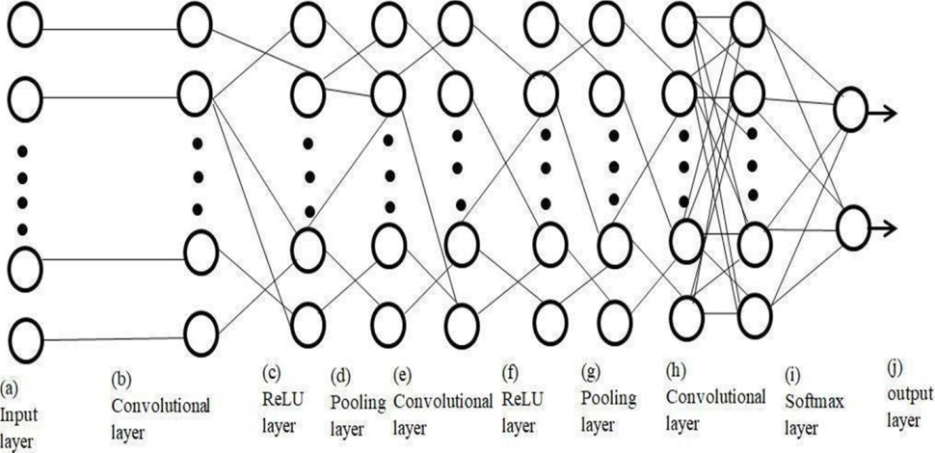

Figure. 18.

Feature Extraction

Feature Selection is the process of retrieving useful features from a group of data. Oftentimes it is found that a lot of features are redundant in the actual prediction of results they do not have any impact on the ML model. Such features unnecessarily hoard computation time and make the process more expensive. Algorithms which identify the optimal subset of features which provide better results than all the features combined are called feature selection algorithms. These algorithms generally evaluate the features based on certain metrics.

They are of three types:
- Filter: These selection algorithms tend to use statistical measures to determine the importance of features. The impact of a feature on the prediction is directly measured as opposed to a combination of features. Tests such as the Chi- Square test are used to determine the relevance of a feature. They do not use any ML algorithms to verify metrics.
- Wrapper: These algorithms iterate throughout the feature subset either from 1 to n or vice versa to determine the optimal n features. Through either forward selection (chooses the best feature and adds the next best feature till n features are achieved), backward selection (eliminates the worst feature till n features are achieved), or exhaustive selection (a combination of forward and backward), the best set of features are chosen. Although these methods provide very good results, they are computationally expensive.
- Embedded: These algorithms employ a combination of Filter and Wrapper methods and perform exhaustive searches using low computation. They claim to possess the best abilities of both the methods. Lasso, Ridge, and Elastic Netsare examples of these methods.

CHAPTER 4

TECHNICAL SPECIFICATIONS

There are multiple aspects of conspiring software for this project since complete processing work done in software, and ample time went in designing software and testing. The PYTHON requests for audio input processes that audio corpus, identifying features, then compare with the trained data frame and results in an approx emotion of the in taken audio.

Classification Using Machine Learning
Machine Learning is a conglomeration of some aspects of data mining, statistical analyses, and pattern recognition. Depending on the type of algorithm used for the problem, different weights are assigned to the features which are responsible for the prediction of results. In essence, an algorithm is a mathematical function. The algorithm is trained on a part of the dataset, where it is allowed to match its function to the expected result. The weights are adjusted and the outputs of the functions are approximated to correspond to a particular class of the result. The model when fitted onto a test data, makes a prediction of the class of the entry based on the functional output. These predictions are plotted against the true values in a confusion matrix and evaluated based on several metrics including accuracy.

Support vector machine
Support Vector Machines have a wide range of applications and are one of the most versatile supervised learning algorithms. SVM represents the inputs as points in space and tries to create a gap among the various categories as accurately in hyper-space as possible. It distinguishes the categories by constructing a hyperplane or a set of hyperplanes in an infinite-dimension space. In addition to its many flexibilities, there exists a technique in SVM known as the ‘kernel trick’, which implicitly maps all inputs into higher feature spaces.
SVM and the kernel trick do not scale well when a large number of inputs or features are involved.

K-nearest neighbor classifier
The KNN algorithm plots all the inputs in feature space and calculates the distance between two points using the Euclidean Distance formula as given below:
√∑(𝑥𝑖 − 𝑦𝑖) ^2 (𝑛 (𝑖=1))
The points in the neighborhoods are weighted uniformly, and in this project, five nearest neighbors are considered. This is a type of instance-based or lazy learning method

Decision tree classifier
Decision Trees use a non-parametrized approach to solve classification problems. This model infers decision rules based on the features and uses little to no data preprocessing. The tree model can handle numerical as well as categorical data very easily. It creates a tree consisting of if-else and other such conditional statements and predicts based on the decisions at each node of the tree. Deeper trees are more complex, but sometimes the classifier builds unnecessarily complex trees. Subtle differences in learning can create entirely different trees which may provide varying results. The decisions, however, use a white-box model and hence can be easily validated and interpreted.

Neural Network
Neural Networks are mechanisms which are modeled after the human brain. They consist of layers of nodes which pass data from layer to another. Each layer consists of a function which assigns weights to the incoming nodes and performs certain mathematical operations on them before forwarding it to the succeeding layer. Although Neural Networks have been around a long time, they rose to prominence due to their application in Deep Learning. Today they are primarily used for performing rigorous analyses on large image datasets.

The name itself is derived from the neuron which is the basic cell in humans that relays data via electrical synapses.
This project classifies the datasets via a Convolutional Neural Network Architecture. A CNN has its origins from the fully connected nature of neurons in animals. The architecture consists of various layers or kernels which actually perform the learning component. The following are important terms to know regarding the CNN Architecture:
- Conv1D: This is a layer (kernel) which convolves a single spatial dimension input into a tensor of outputs.
- Dense: This layer applied the activation function on the incoming data and modifies the weight of the nodes before feeding forward.
- Activation: This is a function which is applied on a layer. These are popular mathematical models which have proven to be beneficial in calculating the weights of nodes. This project uses the following activation functions.
- Flatten: This function is usually used just before the output layer. It converts all inputs shaped (x,) to (x,1).
- Batch Normalization: It standardizes the initiations of the past layer and keeps up the mean actuation near 0 and the enactment standard deviation near 0
- Dropout: This layer randomly sets input units to 0 to help prevent overfitting.
- Input Layer: This is the first layer of the CNN where inputs are delivered.
- Output Layer: This is the final layer of the CNN where predications are made.
- Hidden Layers: These are layers that fall between the input and output layers and perform learning and forwarding of the nodes. The proposed CNN is to have one hidden layer wedged between the input and output layers. The input layer is a Conv1D layer with 32 filters and a kernel size of 2. It uses a tanh activation function. Batch Normalization is performed on this layer and a Dropout of 0.2 is performed. The hidden layer is also a Conv1D layer identical in every way to the previous layer except for having 64 filters. The nodes are first flattened and a Dense layer with 64 filters using the tanh activation function forwards the data but with a Dropout of 0.5. The model is compiled using the following functions:
- Optimizer: This is a function used to change the attributes of the nodes in order to reduce losses. The proposed CNN uses the Adam optimizer.
- Loss: This function calculates the loss between the true and predicted values. The proposed CNN uses the Binary Cross-Entropy loss function.
- Metrics: The model is evaluated with respect to Accuracy during each Epoch (iteration).

Convolutional Neural Network

Convolution layer
The convolutional layer is the basic building block of CNNs and it performs the convolution operation on the input image using a set of learnable filters or kernels. The convolutional layer consists of three main components: the input, the filters, and the output.
Input: The input to the convolutional layer is a three-dimensional tensor of shape (W, H, C), where W is the width of the input image, H is the height of the input image, and C is the number of channels or color depth of the input image.
Filters: The filters or kernels are learnable parameters that are convolved with the input image to extract features. The filters are small matrices of size (F, F, C), where F is the filter size and C is the number of channels in the input image. The number of filters determines the number of features that the convolutional layer will extract from the input image.
Output: The output of the convolutional layer is a three-dimensional tensor of shape (W', H', F), where W' and H' are the spatial dimensions of the output feature map and F is the number of filters. The output feature map represents the activation of each filter at each spatial location of the input image.
The convolutional layer performs the following steps:
Convolution: The input image is convolved with each filter to produce a feature map. Activation: The output of the convolution operation is passed through an activation function such as ReLU (Rectified Linear Unit) to introduce non-linearity into the network. Pooling: The output feature map is down-sampled using a pooling operation such as max pooling or average pooling to reduce the spatial dimensions of the feature map.

Convolutional Layer
The convolutional layer has several hyperparameters that are used to control its behavior and performance. The main hyperparameters of the convolutional layer are:
Filter size: The filter size determines the size of the kernel or filter that is applied to the input image. Typical filter sizes are 3x3, 5x5.

Pooling layer
- Convolutional layers in a convolutional neural framework deliberately apply learned channels to incorporate pictures in order to make feature maps that summarize the proximity of those features in the data.
- Convolutional layers exhibit amazingly ground-breaking, and stacking convolutional layers in significant models grants layers close to the commitment to learning low- level features and layers further in the model to learn high- demander progressively special features, like shapes or express articles.
- Confinement of the component map yield of convolutional layers is that they record the specific circumstance of features in the information. This suggests little improvements in the circumstance of the part in the data picture will realize another component map. This can happen with re-altering, turn, moving, and other minor changes to the information picture.
- A straightforward method to clarify this issue from signal handling is called down sampling. That is the place a lower goals form of an info signal is made that despite everything contains the noteworthy or basic auxiliary components, without the fine detail that may not be as helpful to the task.

Spatial Pooling can be of different types:
- Max Pooling the most significant part from the redressed includes map.
- Global Pooling can be utilized in a model to forcefully sum up the nearness of an element in a picture. It is likewise at times utilized in models as an option in contrast to utilizing a completely associated layer to progress from feature maps to a yield forecast for the model

Technologies Learnt

PYTHON
- Python is a general-purpose interpreted, interactive, object-oriented, and high-level programming language.
- It was created by Guido van Rossum during 1985- 1990
- Monty Python's Flying Circus”, a BBC comedy series from the 1970s.

Why Learn Python?
  - Interpreted Language
  - It supports oops concept
  - It is a platform independent language
  - Line by line executer
  - No need to compile the program
  - Beginner’s easy to learn

Python Applications

- Web Development
- Game Development
- Machine Learning and Artificial Intelligence
- Data Science and Data Visualization
- Web Scraping Applications
- Business Applications
- Audio and Video Applications
- Embedded Applications

Good to know
- The most recent major version of Python is Python 3, which we shall be using in this tutorial. However, Python 2, although not being updated with anything other than security updates, is still quite popular.

- Python 2.0 was released in 2000, and the 2.x versions were the prevalent releases until December 2008. At that time, the development team made the decision to release version 3.0, which contained a few relatively small but significant changes that were not backward compatible with the 2.x versions. Python 2 and 3 are very similar, and some features of Python 3 have been backported to Python 2. But in general, they remain not quite compatible.
- Both Python 2 and 3 have continued to be maintained and developed, with periodic release
updates for both. As of this writing, the most recent versions available are 2.7.15 and
3.6.5. However, an official End of Life date of January 1, 2020 has been
established for Python 2, after which time it will no longer be maintained.
- Python is still maintained by a core development team at the Institute, and Guido is still in charge, having been given the title of BDFL (Benevolent Dictator for Life) by the Python community. The name Python, by the way, derives not from the snake, but from the British comedy troupe Monty Python’s Flying Circus, of which Guido was, and presumably still is, a fan. It is common to find references to Monty Python sketches and movies scattered throughout the Python documentation.
It is possible to write Python in an Integrated Development Environment, such as Thonny, PyCharm, NetBeans or Eclipse which are particularly useful when managing larger collections of Python files.

Python Syntax compared to other programming language
  - Python was designed to for readability, and has some similarities to the English language with influence from mathematics.
  - Python uses new lines to complete a command, as opposed to other programming languages which often use semicolons or parentheses.
  - Python relies on indentation, using whitespace, to define scope; such as the scope of loops, functions and classes. Other programming languages often use curly-brackets for this purpose.

HTML:
HTML stands for Hypertext Markup Language which is a standard markup language for creating Webpages and web applications. We’ve used HTML coding for designing the Webpages of our system being built. Web browsers receive HTML documents from web server but in our case, it is from local storage and renders the documents into multimedia web pages. So, we have learnt a lot many new HTML elements in addition to what we have learnt in the class, and have implemented all of them in the project where ever it is necessary.

CSS:
CSS stands for cascading Style Sheets and CSS is a style sheet language that is used for describing the presentation of a document written in a markup language like HTML. CSS is a technology that is used alongside with HTML and JavaScript.
CSS is designed to enable the separation of presentation ad content, including layout, colors, and fonts.CSS helps us to improve content accessibility, provide more flexibility and control in the specification of presentation characteristics, enable multiple Webpages to share formatting by specifying the relevant CSS in a separate CSS file and reduce complexity and repetition in the structural content.

WEB APPLICATION
Cup is a lightweight WSGI web application system. It is intended to make beginning snappy and simple, with the capacity to scale up to complex applications. It started as a straightforward covering around Werkzeug and Jinja and has gotten one of the most well-known Python web application structures.

Highlights
    - Built being developed worker and quick debugger.
    - Integrated uphold for unit testing.
    - Restful solicitation dispatching.
    - Jinja2 templating.
    - Support for secure treats (customer side meetings)
    - WSGI 1.0 consistent.
    - Unicode based

Libraries

Pandas
Pandas is a library which is primarily used for data analysis and manipulation. It parses data in the form of pandas Data Frames. Some of its functionalities include reading, sorting, merging, aggregating, and reshaping data. It has features to handle missing and null values, and allows for data filtration as well. It also has capabilities to handle time- series data.

NumPy
NumPy is a library that deals with large multi-dimensional arrays and matrices. It performs high-level mathematical operations on these mathematical structures. The NumPy array is a universal data structure to handle images, filter kernels, and feature points.

Matplotlib
Matplotlib is Python’s plotting library and is used along with NumPy to create graphical visualizations and plots. It has a MATLAB-like interface and is also designed to perform functions equivalent to MATLAB on Python. It provides an object-oriented API to embed plots into applications.

Seaborn
Seaborn is a statistical graphing library built on top of matplotlib and is closely integrated with Panda’s data structures. Visualization is its core functionality and it is heavily used for exploratory data analysis and data understanding. It has a wide range of color-palettes and is useful in visualizing a multitude of correlation plots and multivariate distributions.

Scikit-learn
Scikit-learn or sklearn is an open-source ML library written in and written for the Python language. It consists of a collection of algorithms and resources that are useful while performing classification, regression, or clustering on a dataset. It uses NumPy to for high performance linear algebra. The algorithms used in this project: PT, SVC, KNN, GNB, and DTC have been picked form sklearn’s available ML algorithms.

TensorFlow
TensorFlow is an open-source library for performing a range of functions including dataflow and differentiable programming. Developed by Google’s Brain Team, it is used to develop neural network architectures and machine learning. Additionally, it has a special hardware processing unit designed for machine learning.

System Specification
All experiments in this project were performed in Python. All classifications and neural network constructions were performed on Google Collaborator which runs on Python 3 Google Compute Engine backend with no hardware accelerators. These environments were run on a 64-bit Windows 10 OS with an 8GB RAM and a 1TB HDD.
The following versions of the libraries were used:
    - Pandas 1.0.3
    - NumPy 1.0.4
    - Matplotlib 3.0.1
    - Seaborn 1.10.1
    - Sklearn 0.22.2
    - TensorFlow 2.2.0
    - Keras 2.3.0-tf
The platform versions are as follows:
      - Jupyter Notebook 6.0.3
      - Anaconda Navigator 1.9.12
      - Python 3.7.6
      - Google Collaborator 1.0.0

CHAPTER 6

RESULTS & DISCUSSION

6.1 Execution Speed

While training, each step takes about 6ms per step, which makes up around 5 seconds per sample. Our dataset has around 1500 samples of audio, each of which lasts 3 seconds.
Training the whole data set takes around 2 hours, but
it’s a one-time thing. Testing live samples take around 118ms per step, which is around
3.76 seconds on the whole.

Extracting Images from The Datasets:

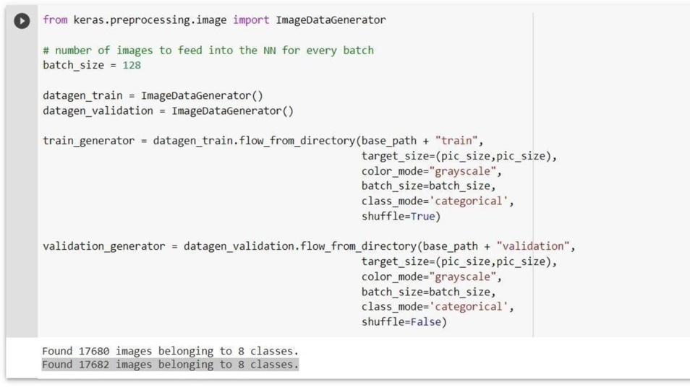

FIGURE-19: EXTRACTING DATASET OF FACE EMOTION

Layers Of CNN For Speech Emotion:
After training numerous models, we got the best validation accuracy of 90% with 18 layers, using CNN model.

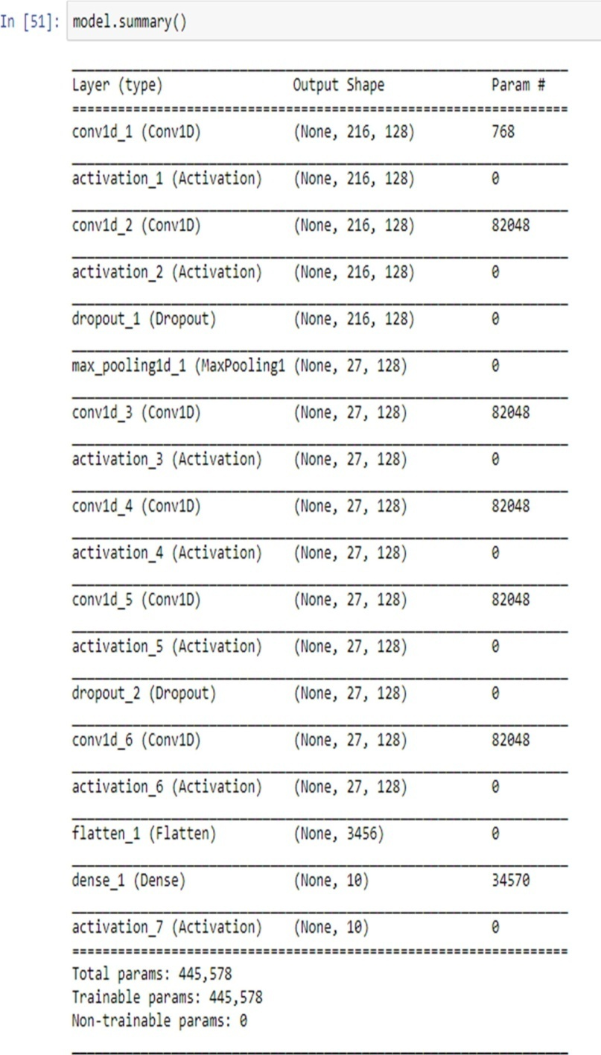

FIGURE – 12: SPEECH LAYERS OF CNN

Face Emotion Recognition Layers Of CNN:

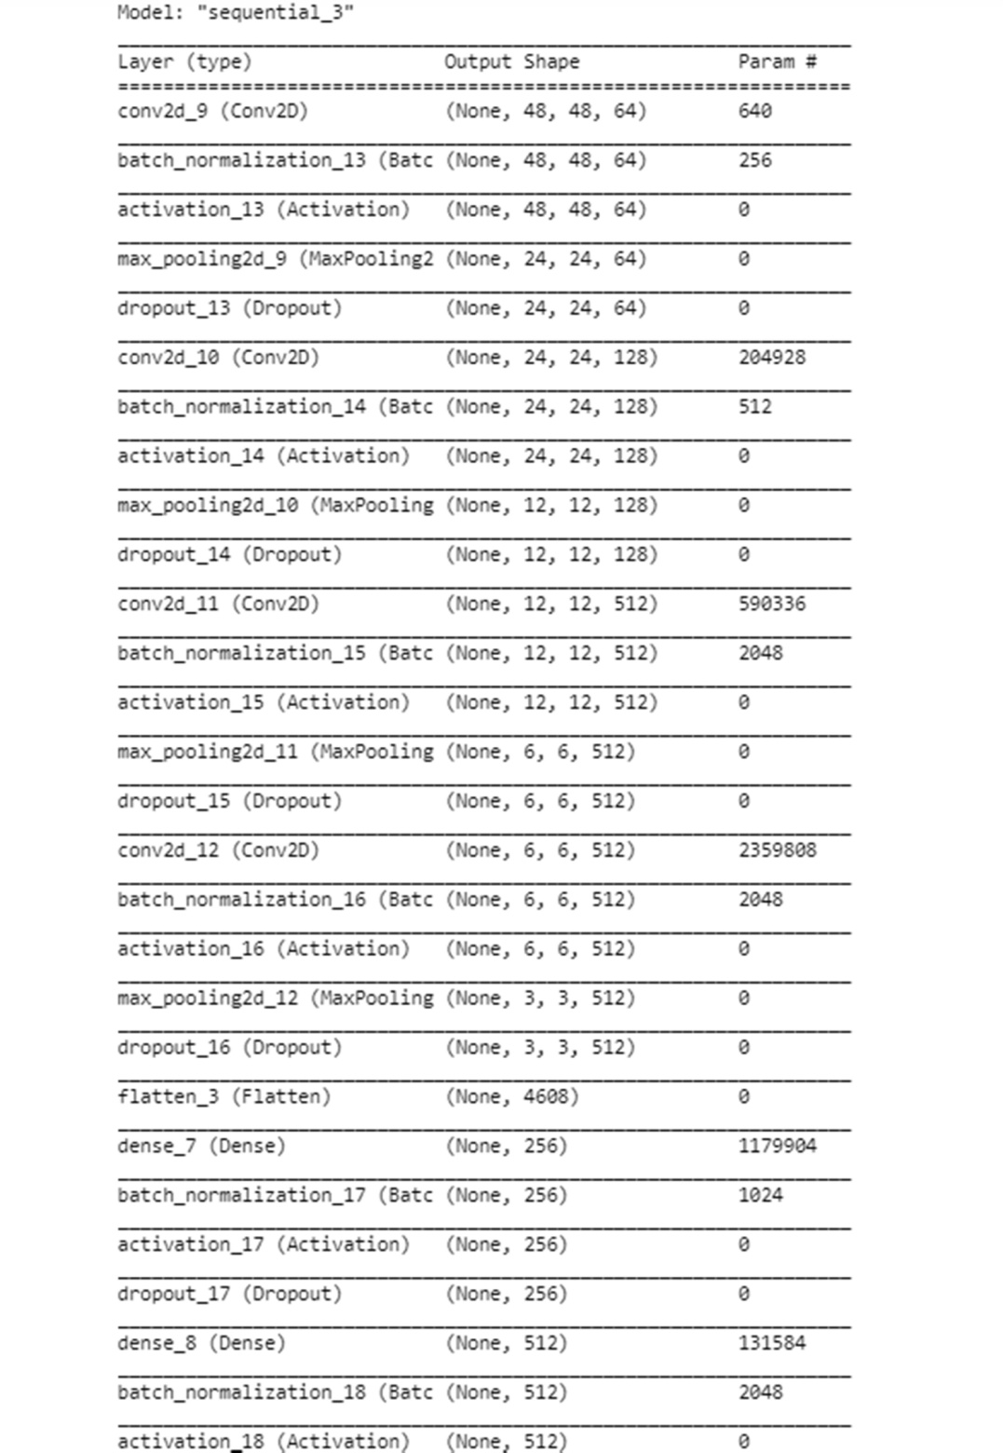

FIGURE -20: FACE EMOTION LAYERS OF CNN

Model Accuracy:

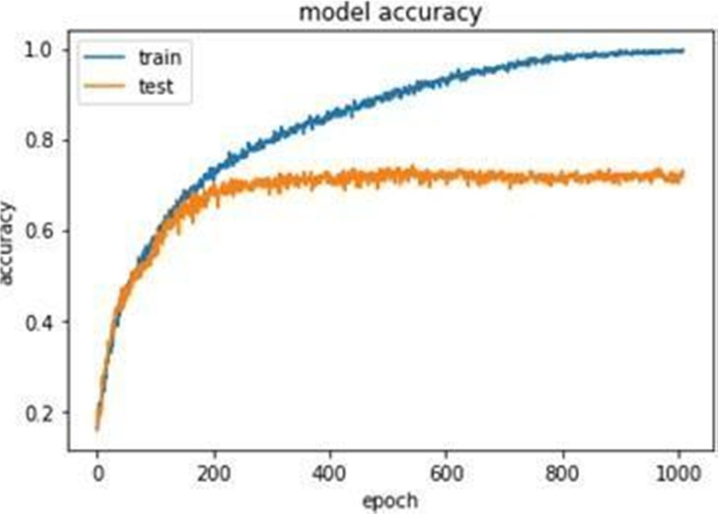

FIGURE – 21: RESULTING ACCURACY FOR SPEECH EMOTION

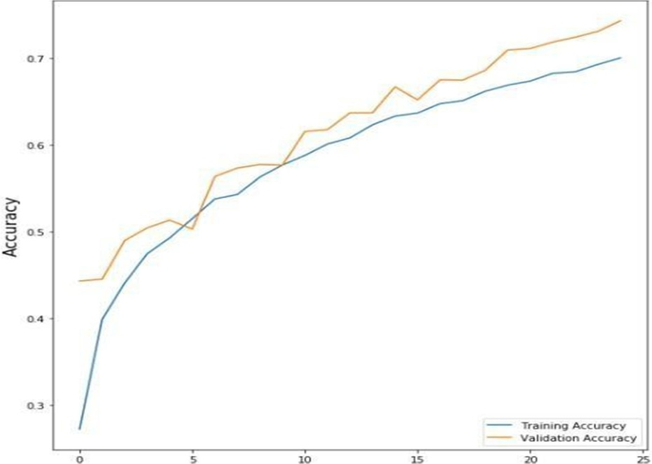

FIGURE-22: RESULTING ACCURACY OF FACE EMOTION

Model Loss
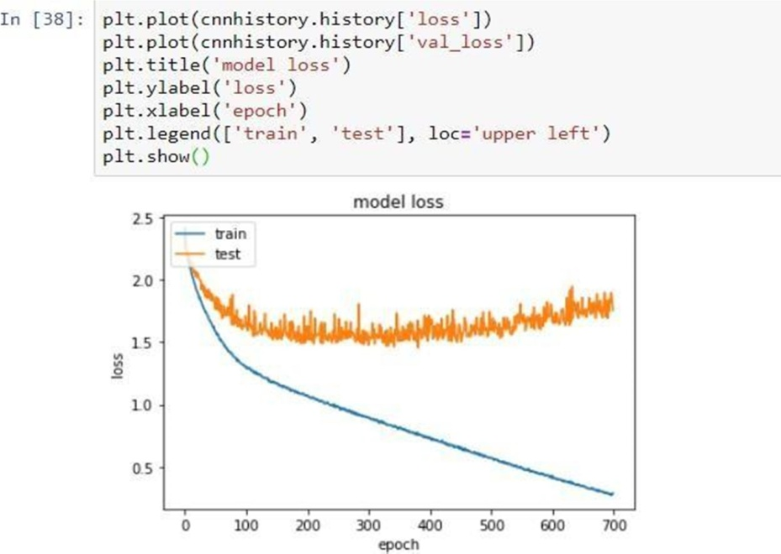

FIGURE 23: SPEECH EMOTION MODEL LOSS

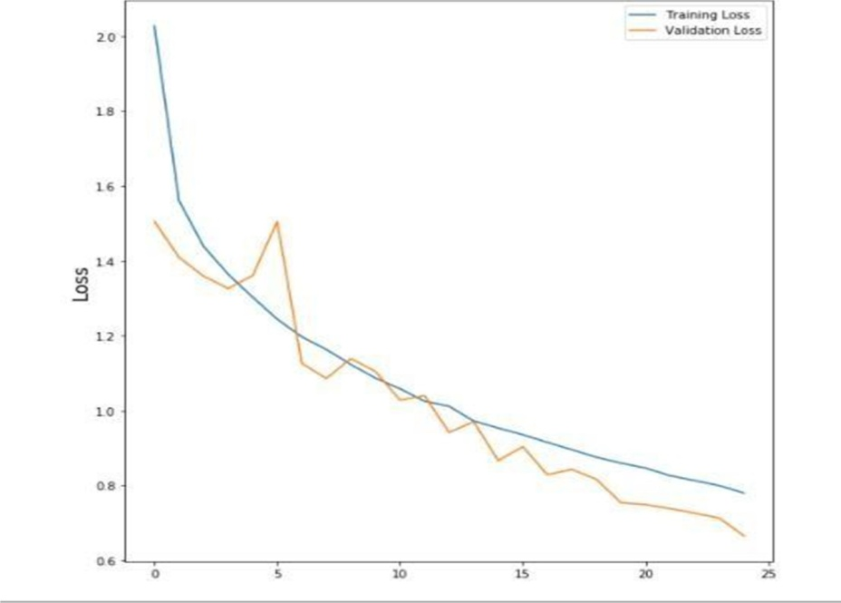

FIGURE 24 FACE EMOTION MODEL LOSS

Code:

SPEECH EMOTION CODE:

import matplotlib.pyplot as plt
import numpy as np import pandas as pd import seaborn as sns import os

# Importing Deep Learning Libraries
from keras.preprocessing.image import load_img, img_to_array from keras.preprocessing.image import ImageDataGenerator from keras.layers import
Dense, Input,Dropout,GlobalAveragePooling2D,Flatten,Conv2D,BatchNormali zation,Activation,MaxPooling2D
from keras.models import Model,Sequential
from keras.optimizers import Adam,SGD,RMSprop picture_size = 48
folder_path = "../input/face-expression-recognition-dataset/images/" expression = 'disgust'
plt.FIGUREure(FIGUREsize= (12,12))
for i in range(1, 10, 1):
plt.subplot(3,3,i)
img = load_img(folder_path+"train/"+expression+"/"+ os.listdir(folder_path + "train/" + expression)[i],
target_size=(picture_size, picture_size)) plt.imshow(img)
plt.show() batch_size = 128
datagen_train = ImageDataGenerator() datagen_val = ImageDataGenerator()

train_set = datagen_train.flow_from_directory(folder_path+"train",
target_size = (picture_size,picture_size), color_mode = "grayscale", batch_size=batch_size, class_mode='categorical', shuffle=True)
test_set = datagen_val.flow_from_directory(folder_path+"validation",
target_size = (picture_size,picture_size), color_mode = "grayscale", batch_size=batch_size, class_mode='categorical', shuffle=False)
from keras.optimizers import Adam,SGD,RMSprop no_of_classes = 7
model = Sequential()

#1st CNN layer
model.add(Conv2D(64,(3,3),padding = 'same',input_shape = (48,48,1))) model.add(BatchNormalization())
model.add(Activation('relu')) model.add(MaxPooling2D(pool_size = (2,2))) model.add(Dropout(0.25))

#2nd CNN layer model.add(Conv2D(128,(5,5),padding = 'same')) model.add(BatchNormalization()) model.add(Activation('relu')) model.add(MaxPooling2D(pool_size = (2,2)))
model.add(Dropout (0.25))

#3rd CNN layer model.add(Conv2D(512,(3,3),padding = 'same')) model.add(BatchNormalization())
model.add(Activation('relu')) model.add(MaxPooling2D(pool_size = (2,2)))
model.add(Dropout (0.25))

#4th CNN layer
model.add(Conv2D(512,(3,3), padding='same')) model.add(BatchNormalization()) model.add(Activation('relu')) model.add(MaxPooling2D(pool_size=(2, 2))) model.add(Dropout(0.25))
model.add(Flatten())

#Fully connected 1st layer model.add(Dense(256)) model.add(BatchNormalization()) model.add(Activation('relu')) model.add(Dropout(0.25))

# Fully connected layer 2nd layer model.add(Dense(512)) model.add(BatchNormalization()) model.add(Activation('relu')) model.add(Dropout(0.25)) model.add(Dense(no_of_classes, activation='softmax')) opt = Adam(lr = 0.0001)
model.compile(optimizer=opt,loss='categorical_crossentropy', metrics=['accuracy'])
model.summary()
from keras.optimizers import RMSprop,SGD,Adam
from keras.callbacks import ModelCheckpoint, EarlyStopping, ReduceLROnPlateau

checkpoint = ModelCheckpoint("./model.h5", monitor='val_acc', verbose=1, save_best_only=True, mode='max')

early_stopping = EarlyStopping(monitor='val_loss',
min_delta=0, patience=3, verbose=1,
restore_best_weights=True
)

reduce_learningrate = ReduceLROnPlateau(monitor='val_loss', factor=0.2,
patience=3, verbose=1, min_delta=0.0001)

callbacks_list = [early_stopping,checkpoint,reduce_learningrate]

epochs = 48

model.compile(loss='categorical_crossentropy', optimizer = Adam(lr=0.001), metrics=['accuracy'])
history = model.fit_generator(generator=train_set,
steps_per_epoch=train_set.n//train_set.batch_size, epochs=epochs,
validation_data = test_set,
validation_steps = test_set.n//test_set.batch_size, callbacks=callbacks_list
)
plt.style.use('dark_background') plt.FIGUREure(FIGUREsize=(20,10)) plt.subplot(1, 2, 1)

plt.suptitle('Optimizer : Adam', fontsize=10) plt.ylabel('Loss', fontsize=16) plt.plot(history.history['loss'], label='Training Loss') plt.plot(history.history['val_loss'], label='Validation Loss') plt.legend(loc='upper right')
plt.subplot(1, 2, 2) plt.ylabel('Accuracy', fontsize=16)
plt.plot(history.history['accuracy'], label='Training Accuracy') plt.plot(history.history['val_accuracy'], label='Validation Accuracy') plt.legend(loc='lower right')
plt.show()

OUTPUT

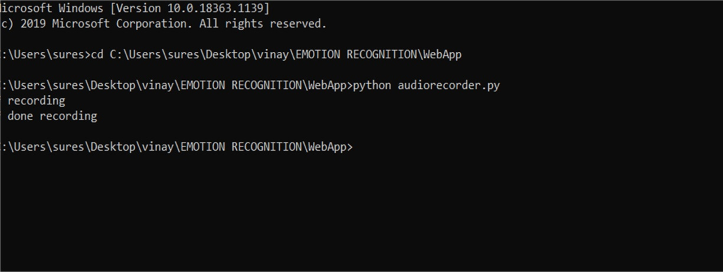

FIGURE-25: AUDIO RECORDING

FACE EMOTION CODE:

from keras.models import load_model from time import sleep
from tensorflow.keras.utils import img_to_array from keras.preprocessing import image

import cv2
import numpy as np
face_classifier = cv2.CascadeClassifier(r'haarcascade_frontalface_default.xml') classifier =load_model(r'model.h5')

emotion_labels = ['Angry','Disgust','Fear','Happy','Neutral', 'Sad', 'Surprise']

cap = cv2.VideoCapture(0) print("done")
while True:
_, frame = cap.read() labels = []
gray = cv2.cvtColor(frame,cv2.COLOR_BGR2GRAY) faces = face_classifier.detectMultiScale(gray)

for (x,y,w,h) in faces: cv2.rectangle(frame,(x,y),(x+w,y+h),(0,255,255),2) roi_gray = gray[y:y+h,x:x+w]
roi_gray = cv2.resize(roi_gray,(48,48),interpolation=cv2.INTER_AREA)

if np.sum([roi_gray])!=0:
roi = roi_gray.astype('float')/255.0 roi = img_to_array(roi)
roi = np.expand_dims(roi,axis=0) prediction = classifier.predict(roi)[0] label=emotion_labels[prediction.argmax()] label_position = (x,y)

cv2.putText(frame,label,label_position,cv2.FONT_HERSHEY_SIMPLEX,1,(0,255,0),2) else:
cv2.putText(frame,'No Faces',(30,80),cv2.FONT_HERSHEY_SIMPLEX,1,(0,255,0),2)
cv2.imshow('Emotion Detector',frame) if cv2.waitKey(1) & 0xFF == ord('q'):
break

cap.release() cv2.destroyAllWindows()

Results:
This section presents the results obtained when applying several deep learning models to NTC. The influence of several important hyper-parameters and design decisions is analyzed, in particular: the model architecture, the features selected and the number of packets extracted from the network flows.
In order to appreciate the detection quality of the different options, and considering the highly unbalanced distribution of service labels, we provide the following performance metrics for each option: accuracy, precision, recall, and F1. Considering all metrics, F1 can be considered the most important metric in this scenario. F1 is the harmonic mean of

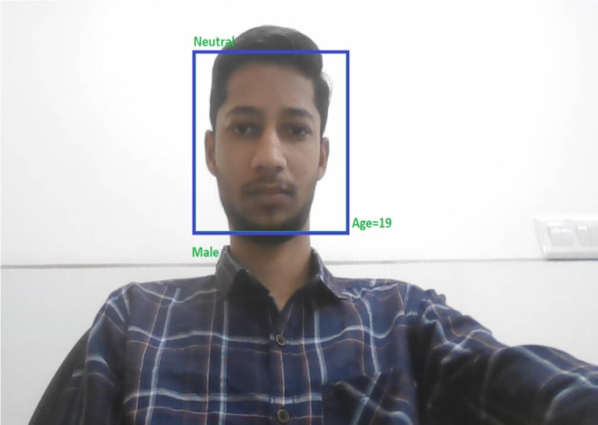

FIGURE 26: NEUTRAL EXPRESSION

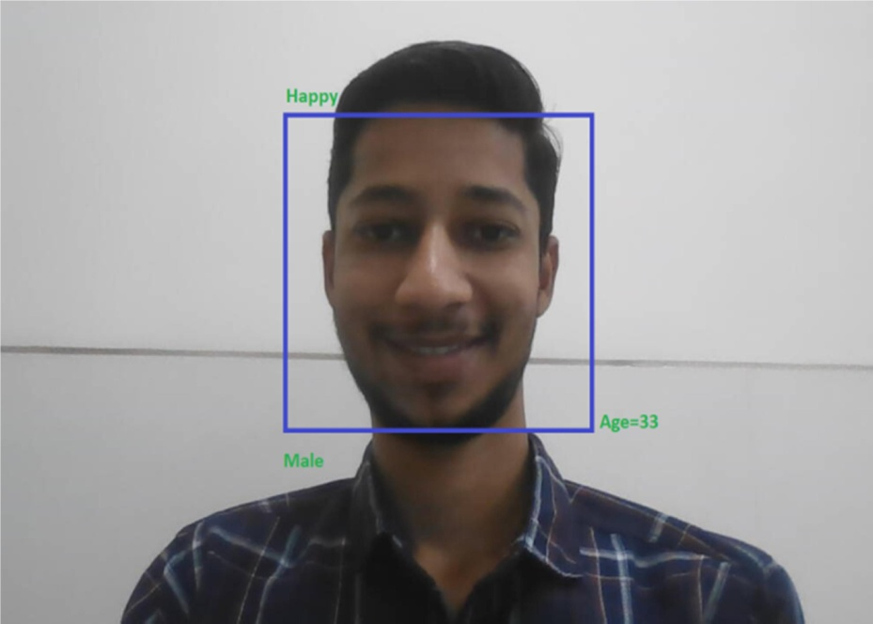

3
FIGURE 27: HAPPY EMOTION DETECTED

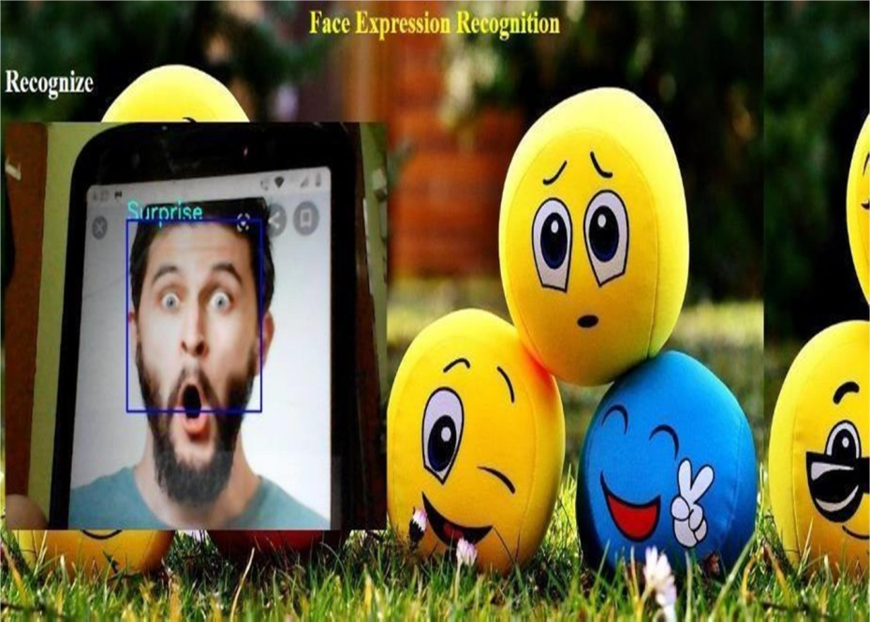

FIGURE 28: SURPRISE EMOTION DETECTED

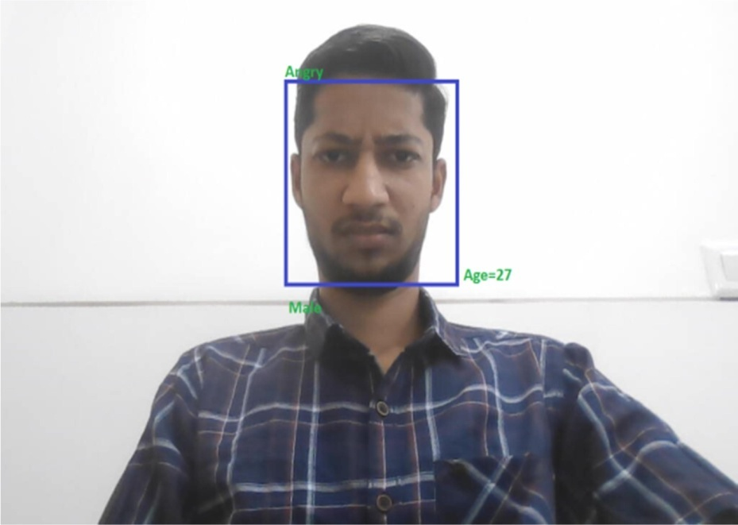

FIGURE 29 ANGRY EMOTION DETECTED

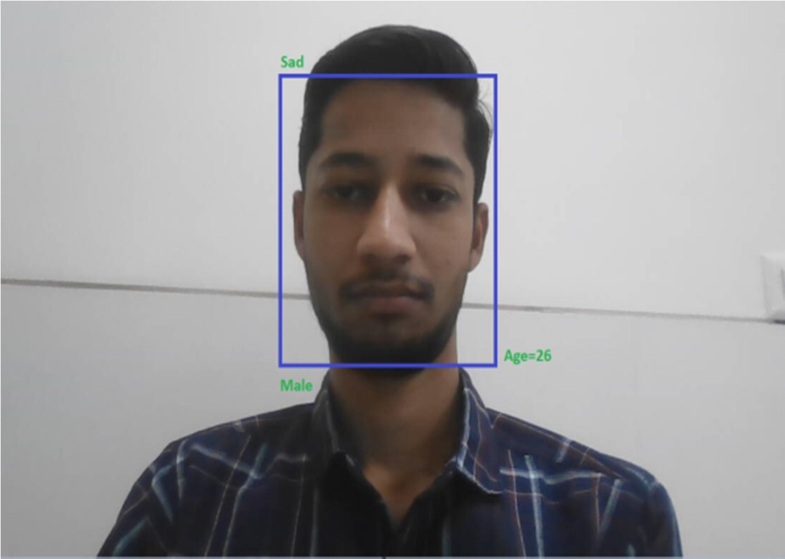

FIGURE 30: SAD EMOTION DETECTED

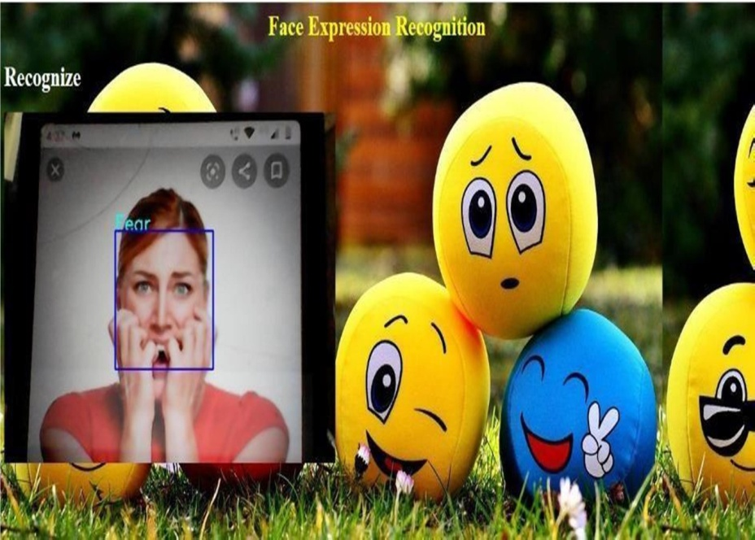

FIGURE 31: FEAR EMOTION DETECTED
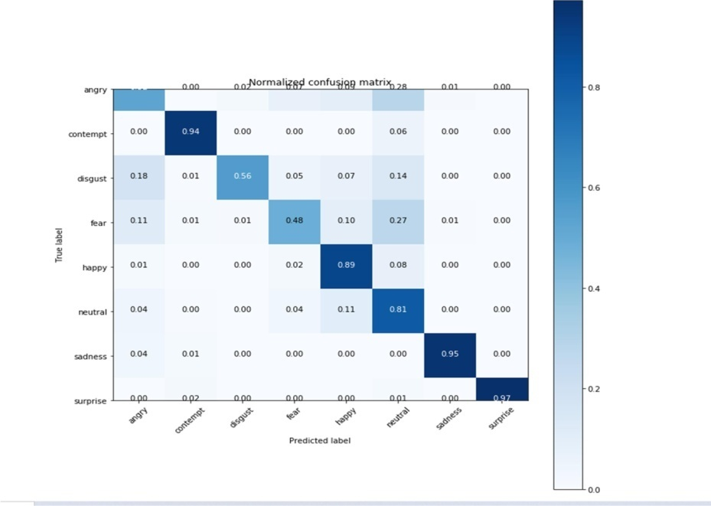

FIGURE 32: CONVOLUTION MATRIX OF FACE EMOTIONS

CHAPTER 7 CONCLUSION AND FUTURE WORK

Conclusions
In this project, a LeNet architecture primarily based on a six-layer convolutional neural community is implemented to classify human facial expressions i.e., sad, happy, surprise, fear, anger, disgust, and neutral. The device has been evaluated using Accuracy, Precision, Recall and F1-rating. The classifier performed an accuracy of 85.77 %. Various experiments are conducted by changing the several parameters like dimension of the model, number of epochs, changing the partition ratio between training and test data set.
Different accuracy was found for different experiments. A lighter CNN architecture with 80% of training data and 20% of test data gave good results compared to deeper CNN architecture while classifying among ten classes. The accuracy of this model was found to be 80%. The performance of the deeper CNN model was found to be very good when the classification was among two classes. The reason is there were a greater number of training samples available to classify among two classes. When the same model was used to classify among ten classes the training dataset was divided into ten labels this led to the fewer number of training samples available for each class.

Future Work
In the future paintings, the version may be prolonged to coloration pictures. This will permit analysis of the efficacy of pre-skilled models which includes AlexNet or VGGNet for facial emotion recognition. This led to the poor accuracy of the model. With the greater number of training samples available for each class and with the help of GPUs to speed up the training process more accuracy can be achieved in the future enhancements

REFERENCES

- MinSeop Lee ,Yun Kyu Lee , Myo-Taeg Lim 1, and Tae-Koo Kang 2, Emotion Recognition Using Convolutional Neural Network with Selected Statistical Photoplethysmogram 19 May 2020
- Peng Song; Wenming Zheng Feature Selection Based Transfer Subspace Learning for Speech Emotion Recognition 31 January 2018
- Monorama Swain, Aurobinda Routray ,P. Kabisatpathy Databases, features and classifiers for speech emotion recognition: a review 19 January 2018
- Leila Kerkeni Youssef Serrestou; Mohamed Mbarki; Kosai Raoof; Mohamed Ali Mahjoub A review on speech emotion recognition: Case of pedagogical interaction in classroom 23 October 2017
- Cheng He,Yun-jin Yao,Xue-song Ye An Emotion Recognition System Based on Physiological Signals Obtained by Wearable Sensors 01 October 2016
- Christos-Nikolaos Anagnostopoulos, Theodoros Iliou & Ioannis Giannoukos Features and classifiers for emotion recognition from speech: a survey from 2000 to 2011 09 November 2012
- Yu Gu, Eric Postma,Hai-Xiang Lin,Jaap van den Herik Speech emotion recognition using voiced segment selection algorithm August 2016
- Fabien Ringeval, Björn Schuller, Michel Valstar,Shashank Jaiswal Erik Marchi,Denis Lalanne AV+EC 2015: The First Affect Recognition Challenge Bridging Across Audio,
Video, and Physiological Data October 2015
- Christopher Pal,Samira Ebrahimi KahouVincent Michalski,Kishore Konda,Roland Memisevic Recurrent Neural Networks for Emotion Recognition in Video November 2015
- Wei-Long Zheng, Bao-Liang Lu Personalizing EEG-based affective models with transfer learning July 2016
- Carlos Busso, Zhigang Deng *, Serdar Yildirim, Murtaza Bulut, Chul Min Lee, Abe Kazemzadeh, Sungbok Lee, Ulrich Neumann* , Shrikanth Narayanan Analysis of Emotion Recognition using Facial Expressions, Speech and Multimodal Information October 2004
- Anbhag Yao, Junchao Shao, Ningning Ma, and Yurong Chen. Capturing au- aware facial
features and their latent relation for emotion recognition in the wild.In Proceeding of the 2015 ACM on International Conference on Multimodal Interaction, pages 451-458.ACM, 2015
- Ninad Mehendale Facial emotion recognition using convolutional neural networks (FERC) 18 February 2020
- Ruhul Amin Khalil; Edward Jones; Mohammad Inayatullah Babar; Tariqullah Jan; Mohammad Haseeb Zafar; Thamer Al Hussain Speech Emotion Recognition Using Deep Learning Techniques: A Review 19 August 2019
- E. Gunawan, H. Ardinata, and R. Yustitia, "Facial Emotion Recognition using Deep Learning," 2019 IEEE 5th International Conference on Engineering Technologies and Social Sciences (ICETSS), Bali, Indonesia, 2019, pp. 1-4.
- K. B. Kejriwal and P. C. Pandey, "Emotion Detection using Convolutional Neural Networks," 2019 International Conference on Computer, Communication, and Signal Processing (ICCCSP), Chennai, India, 2019, pp. 1-6.
- S. Gupta and G. Sharma, "A Comparative Study of Deep Learning Techniques for Emotion Recognition," 2019 IEEE 3rd International Conference on Trends in Electronics and Informatics (ICOEI), Tirunelveli, India, 2019, pp. 437-442.
- Y. Zhang and W. Zhang, "Facial Expression Recognition Based on Deep Learning," 2019 IEEE International Conference on Consumer Electronics - China (ICCE-China), Changsha, China, 2019, pp. 1-5.
- L. Yang, J. Huang, and Z. Yu, "Emotion Recognition Using Deep Learning and Speech Signals," 2019 International Conference on Artificial Intelligence in Information and Communication (ICAIIC), Okayama, Japan, 2019, pp. 91-94.
- A. Kumar and A. Jain, "Facial Emotion Recognition using Deep Learning Techniques," 2019 International Conference on Intelligent Sustainable Systems (ICISS), Chennai, India, 2019, pp. 474-478.
- Y. Zhang and W. Zhang, "Facial Expression Recognition Based on Deep Learning," 2019 IEEE International Conference on Consumer Electronics - China (ICCE-China), Changsha, China, 2019, pp. 1-5.
- V. Dey, S. Bhattacharya, and D. De, "Facial Emotion Recognition using Deep Learning Techniques," 2019 10th International Conference on Computing, Communication and Networking Technologies (ICCCNT), Kanpur, India, 2019, pp. 1-5.
- S. Chen and Y. Wang, "Emotion Recognition using Deep Learning with Facial
Expression and Speech," 2019 IEEE 4th International Conference on Cloud Computing and Big Data Analysis (ICCCBDA), Chengdu, China, 2019, pp. 310-315.
- A. Agarwal, N. Bansal, and A. Singh, "Emotion Detection using Facial Expression Analysis with Deep Learning," 2020 International Conference on Information Technology and Knowledge Management (ICITKM), Gurugram, India, 2020, pp. 1-6.
- S. K. Sharma and K. R. K. Kumar, "Emotion Recognition from Speech using Deep Learning," 2020 11th International Conference on Computing, Communication and Networking Technologies (ICCCNT), Kharagpur, India, 2020, pp. 1-6.
- Y. Li, L. Li, and J. Li, "Emotion Recognition based on Deep Learning and Physiological Signals," 2020 IEEE 6th International Conference on Computer and Communications (ICCC), Chengdu, China, 2020, pp. 131-135
- M. Alreshoodi and A. Alshehri, "Emotion Detection from Arabic Text Using Deep Learning," in IEEE Access, vol. 7, pp. 129340-129350, 2019.
- S. Ghosh, S. Ganguly and N. Dey, "Emotion Detection in Twitter Data Using Deep Learning Techniques," 2019 IEEE 19th International Conference on Data Mining Workshops (ICDMW), Beijing, China, 2019, pp. 1038-1045.
- M. R. Habib, M. Z. Rahman and M. A. Haque, "Emotion Detection from Bangla Text Using Deep Learning Techniques," 2019 3rd International Conference on Intelligent Computing and Control Systems (ICICCS), Madurai, India, 2019, pp. 572-577.
- R. Han, C. Chen, X. Wang and W. Li, "Emotion Detection of Short Text Based on Deep Learning," 2019 4th International Conference on Computational Intelligence and Applications (ICCIA), Beijing, China, 2019, pp. 232-236.
- C. Li, B. Li and H. Lu, "Emotion Detection from Text Using Deep Learning and Semantic Analysis," 2019 IEEE International Conference on Multimedia and Expo Workshops (ICMEW), Shanghai, China, 2019, pp. 1-6.
- T. Ouyang and X. Dong, "Emotion Detection in Microblogs Based on Deep Learning and Convolutional Neural Network," 2019 IEEE International Conference on Internet of Things (iThings) and IEEE Green Computing and Communications (GreenCom) and IEEE Cyber, Physical and Social Computing (CPSCom) and IEEE Smart Data (SmartData), Atlanta, GA, USA, 2019, pp. 1931-1937.
- P. Ram and P. S. Hiremath, "Emotion Detection from Text using Deep Learning and Natural Language Processing Techniques," 2019 International Conference on Intelligent Computing and Control Systems (ICICCS), Madurai, India, 2019, pp. 518-522.
- M. Wang, J. Zhao, Y. Xu and W. Sun, "Emotion Detection in Text using Deep Learning and Word Embeddings," 2019 IEEE International Conference on Big Data (Big Data), Los Angeles, CA, USA, 2019, pp. 1956-1963.
- J. Xie, C. Zhang, Q. Cai and W. Wu, "A Deep Learning-Based Emotion Detection System for English and Chinese Text," 2019 IEEE 8th Data Driven Control and Learning Systems Conference (DDCLS), Hong Kong, China, 2019, pp. 497-502.
- Y. Zhang and X. Liu, "Emotion Detection in Chinese Text using Deep Learning and Word Embeddings," 2019 IEEE 3rd Information Technology, Networking, Electronic and Automation Control Conference (ITNEC), Chengdu, China, 2019, pp. 1068-1072.
- B. Zhang, Z. Yan and H. Zhu, "Emotion Detection in Microblogs Using Deep Learning with Attention Mechanism," 2019 IEEE 2nd International Conference on Information and Computer Technologies (ICICT), Cairo, Egypt, 2019, pp. 216-221.
- M. Zhang, Q. Liu and Y. Li, "Emotion Detection in Social Media Text using Deep Learning with Attention Mechanism," 2019 IEEE 4th International Conference on Cloud Computing and Big Data Analysis

USER MANUAL

Speech Emotion Recognition
  - STEP 1: Set up a laptop with working microphone and also Anaconda tools init
  - STEP 2: Now, execute audiorecorder.py to record audio using a microphone.
  - STEP 3: Train the application if it is 1st time execution (run each cell in order)
  - STEP 4: Run the last few commands after training.
  - STEP 5: Application displays emotion of voice

Face Emotion Recognition
    - STEP 1: Set up a laptop with working webcam and also Anaconda tool in it
    - STEP 2: Train the application if it is 1st time execution (run each cell in order) in Jupyter notebook.
    - STEP 3: Now, execute faceemotionrecognition.py in command prompt
    - STEP 4: Register and Login then allow webcam to detect the face.
    - STEP 5: Application displays emotion of face

